CHAPTER 1
INTRODUCTION
This chapter discusses the secondhand car trade market, its scope in India and drawbacks of the traditional system. It also discusses the blockchain and its advantages, how it is used to tackle the disadvantages of the traditional second-hand car trade system.
- SECOND HAND CAR TRADE
The used car trade is an active business that involves the purchasing and selling of used cars, either through private transactions or through used car dealership operations. Because used cars have lower ownership costs than new cars, the market has grown significantly in recent years. Furthermore, the pandemic has increased demand for individual mobility, which has contributed to the market's rise.
The used automobile trade business in India is a huge and important component of the automotive industry. The country's burgeoning middle class and young population, spurred by rising disposable income and desire for luxury used cars, are the primary drivers of this massive expansion. However, the traditional used automobile market in India has several problems that limit its growth and potential.

One of the most common issues in the traditional used car industry is a lack of trust due to data asymmetry. This lack of a system for tracking a vehicle's history renders it subject to vehicle tampering and other abnormalities, such as odometer fraud. The absence of openness results in data asymmetry between buyers and sellers, which leads to information concealment and other discrepancies. Furthermore, the value of a used car depreciates over time, making it harder for sellers to obtain a reasonable price.
Also, the traditional used car market in India is time-consuming, labour-intensive, and expensive. Buyers and sellers may need to spend hours analysing and negotiating with each other, while private sellers may need to pay for advertising or repairs to attract buyers. Dealerships may also demand exorbitant fees and charges for their services, making transactions between buyers and sellers prohibitively expensive.
  - BLOCKCHAIN
A blockchain, at its heart, is a decentralised and distributed digital ledger that enables secure and transparent data storage and transfer. The system consists of a network of nodes or computers, each of which keeps a copy of the ledger, and each block in the chain holds a record of a transaction or data point.
When a new transaction or data point is added to the blockchain, the network first verifies it through a process known as consensus. A complicated cryptographic technique ensures that the transaction is genuine and that all network nodes agree on the status of the ledger. Once validated, the transaction is moved to a new block on the chain. Each block contains a hash or digital fingerprint of the previous block in the chain, resulting in an unbroken, tamper-proof chain of blocks. Several significant factors contribute to the blockchain's security. Furthermore, the use of cryptographic methods and digital signatures assures that each blockchain transaction is secure and tamper-proof.
Immutability is another important aspect of blockchain. Once a block is added to the chain, it cannot be changed or deleted without network consensus. This means that the data on the blockchain is extremely secure and impervious to alteration or corruption.
Overall, storing and transferring data with blockchain technology is very safe, transparent, and effective. Its decentralised and unchangeable nature offers considerable advantages over conventional databases and other methods of record-keeping, and businesses and organisations around the world are increasingly adopting it. [10]
  - OBJECTIVE
Comparing blockchain technology to conventional databases and other record-keeping methods, there are a few significant benefits. Security, transparency, efficiency, decentralisation, and immutability are some of the benefits of blockchain that are most notable.
The security of blockchain technology is one of its main benefits. Blockchain's decentralised structure and reliance on cryptographic techniques for transaction validation make it extremely safe. The blockchain is extremely resistant to hacking and fraud because it is dispersed throughout a network of nodes and lacks a single point of control or authority. A further layer of protection is added using cryptographic methods.
The transparency of blockchain is another benefit. The blockchain offers a transparent and impenetrable record of all transactions because it is a distributed ledger. In a variety of sectors this can serve to boost responsibility and trust.
Another significant benefit of blockchain technology is efficiency. Because blockchain can speed up transactions and reduce the need for middlemen, helping to streamline company processes. This can aid in reducing expenses and raising efficiency across a wide range of industries, including banking and healthcare. Blockchain can be used, for instance, to automate and streamline the process of maintaining medical records, which can assist to lower errors and enhance patient outcomes.
Another significant benefit of blockchain technology is decentralisation. Blockchain does not rely on a single point of control or authority because it is decentralised. This can help to improve the security and stability of networks by making it more resistant to attacks or failures.
And lastly, blockchain technology is extremely immutable. Data that has been added to the blockchain cannot be changed or removed without network consensus. This indicates that the data's integrity on the blockchain is extremely secure and impervious to manipulation or corruption. The blockchain's immutability makes it the perfect solution for applications that need a high degree of security and trust, including financial transactions or the storage of medical records.
In conclusion, blockchain technology has several important advantages over conventional databases and other record-keeping methods. Its security, openness, effectiveness, decentralisation, and immutability make it perfect for a variety of applications and it is best suitable to address the data asymmetry in the traditional second-hand car trade market.
  - MOTIVATION
A wide range of stakeholders, including car dealerships, buyers, sellers, banks, and regulators, are involved in the used car trade market. The conventional method of buying and selling used cars frequently entails a substantial amount of paperwork, middlemen, and verification procedures, which may be expensive, time-consuming, and prone to fraud.
Blockchain technology has the potential to revolutionise the used car market by offering a safe, open, and effective method for storing and transferring ownership of vehicles. By utilising blockchain, participants in the used automobile market can establish a decentralised vehicle registry where all pertinent data about a vehicle is kept in a secure and open format.
A permissioned blockchain network, in which only authorised users are allowed to view and edit the ledger, might be used to establish the decentralised automobile register. In order to create a digital record of the vehicle's ownership history, maintenance history, and other pertinent information, each vehicle might be given a special identification number, such as a Vehicle Identification Number (VIN).
A new block may be uploaded to the blockchain every time a vehicle changes hands, recording the transaction as well as the VIN and other pertinent information. With the use of the blockchain, an unchangeable chain of ownership would be created, enhancing the transaction process' transparency and trustworthiness.
Additionally, the transfer of ownership and other elements of the trading process might be automated using smart contracts. For instance, once payment has been received, a smart contract may be made to immediately transfer ownership of a vehicle to the buyer. This will limit the possibility of fraud and eliminate the need for middlemen like banks or escrow services.
The sector of selling used cars could undergo a revolution thanks to the introduction of digital tokens. Vehicle ownership might be represented by digital tokens that can be exchanged on a blockchain-based market.
Stakeholders in the used car trade can dramatically improve efficiency, transparency, and trust in the transaction process by utilising blockchain technology. There would be no need for middlemen, no chance of fraud, and a more secure way to store and transfer ownership of cars through decentralised vehicle registry, smart contracts, and digital tokens.

CHAPTER 2
ETHEREUM
This chapter discusses Ethereum technology and depicts a simple working of the web3 decentralized applications.
2.1 INTRODUCTION TO ETHEREUM
Ethereum is a decentralized, open source blockchain platform that enables developers to build decentralized applications (DApps) using smart contracts.
Ethereum offers a more adaptable framework for developers to construct a variety of blockchain-based apps than Bitcoin, which is largely utilised as a digital money. Ethereum's smart contract technology, which enables programmers to design self-executing contracts that may automatically initiate transactions when certain circumstances are satisfied, is its key feature.
Ether (ETH), a cryptocurrency created specifically for Ethereum, is used to pay for computational services and transaction fees on the Ethereum network. Like Bitcoin, Ether is utilised as a store of value as well. Ethereum has become the preferred platform for creating decentralised apps in the blockchain and cryptocurrency industries. It has also influenced the creation of other blockchain systems, such as Binance Smart Chain, Polkadot, and Cardano.

Because of its ability to create decentralised apps (DApps) through the use of smart contracts, Ethereum is a preferred option for recording vehicle history on the blockchain. Smart contracts make it possible to preserve the automotive history in an unalterable and tamper-proof manner, giving buyers and sellers a safe and transparent means to view the vehicle's history.
In addition, developers may easily write unique contracts to store and manage vehicle history data thanks to Ethereum's Solidity programming language, which is created expressly for developing smart contracts. Ethereum has a sizable and vibrant development community, so there is a tonne of resources accessible for developers to learn from and hone their abilities.
The public blockchain for Ethereum is also very safe and decentralised, meaning that no one organisation has control over the network. This makes sure that the data is visible to anybody with an internet connection and that it cannot be altered or censored in any way.
2.2 DAPP
A software program known as a "DApp" (decentralized application) runs on a decentralized network like a blockchain. DApps take advantage of the decentralized nature of blockchain technology to enable peer-to-peer interactions without intermediaries, in contrast to traditional apps that run on a centralized server. Figure 2.2 shows the working of DApps.
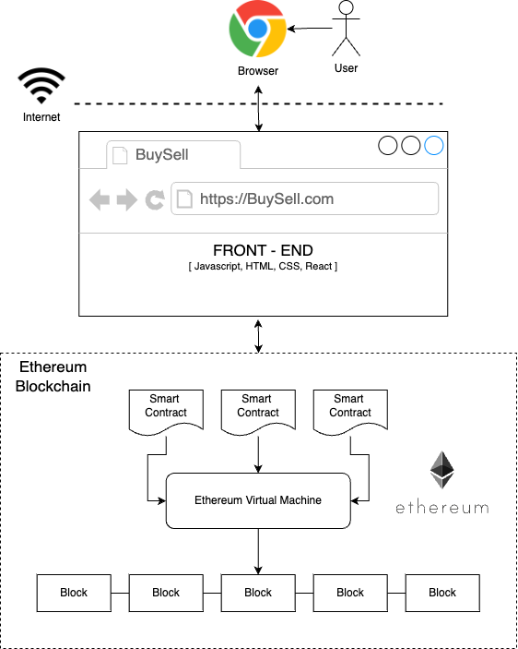
Figure 2. Working of DApps
Simple Working of DApps:
- The Ethereum blockchain is a decentralized public ledger that records transactions between accounts. The accounts can be owned by individuals or organizations, and they interact with each other by sending transactions to the network.
- A front-end application is created using HTML, CSS, and JavaScript that interacts with the Ethereum blockchain.
- To connect the front-end application to the Ethereum network, a service like Infura is used. Infura provides access to the Ethereum network via an API. The front-end application can send requests to the Infura API to interact with the Ethereum network.
- To authenticate and authorize transactions, MetaMask is used. MetaMask is a browser extension that allows users to manage their Ethereum accounts and sign transactions. The user installs the MetaMask extension in their browser and creates an Ethereum account. The user can then connect their MetaMask account to the front-end application and authorize transactions.
- When the user interacts with the front-end application, the application sends a request to the Infura API, which then sends the transaction to the Ethereum network. The transaction is validated and confirmed by the network, and the result is returned to the front-end application.
- The front-end application displays the results of the transaction to the user. The user can then interact with the application further or close the application.
Overall, this process allows for a decentralized and secure way of interacting with the Ethereum blockchain using a user-friendly interface. The use of Infura and MetaMask simplifies the process for the end-user, while still maintaining the security and integrity of the transactions on the blockchain.

CHAPTER 3
LITERATURE SURVEY
The concept of blockchain was introduced as a decentralized digital currency system that enables secure transactions between parties without the involvement of intermediaries like banks or financial institutions. The system is built on a public ledger known as the blockchain, which records all transactions and ensures their security and accuracy. The blockchain is essentially a distributed database that is maintained by a network of computers, and it is used to verify and record transactions through a consensus mechanism called proof-of-work. This involves solving complex mathematical puzzles, and once a block of transactions is verified, it is added to the blockchain, creating an unalterable record of all transactions on the network.
Today, blockchain technology has evolved beyond digital currency and is being used in various applications such as supply chain management, voting systems, and more. Nonetheless, the Bitcoin system proposed in the paper remains one of the most prominent and widely used cryptocurrencies in the world [8].
There are several benefits of using blockchain technology for accident and insurance registration, such as decentralization, immutability, automation, and enhanced privacy and security. The use of blockchain can help prevent fraud, errors, and manipulation, ensure data integrity and transparency, reduce costs and time, and protect the privacy of individuals involved in the process [1].
Blockchain technology offers several advantages that make it an attractive option for various applications. One of the most significant benefits of blockchain is its decentralized nature, which eliminates the need for a central authority to manage and control transactions. This enhances security and prevents fraud, errors, and manipulation. Another advantage is the immutability of the blockchain, which means that once a transaction is recorded, it cannot be altered or deleted, ensuring the integrity of the data. Additionally, blockchain allows for the automation of transactions using smart contracts, which can reduce the time and cost of executing transactions. The enhanced privacy and security provided by the blockchain is also noteworthy, as data is stored in a decentralized and encrypted manner. Overall, blockchain technology has the potential to increase efficiency, reduce costs, enhance security, and improve transparency and trustworthiness in various industries and applications [3].
Blockchain technology has numerous use cases across a wide range of domains and industries. One of the most prominent and well-known domains for blockchain is cryptocurrency, where it serves as the underlying technology for creating secure, decentralized digital currencies like Bitcoin and Ethereum. Beyond cryptocurrencies, blockchain can be used in supply chain management to ensure the provenance, authenticity, and quality of goods and materials. Other potential use cases of blockchain include identity verification, creating digital identities that are tamper-proof and immutable, and voting systems, which can be made more secure and transparent using blockchain. Additionally, blockchain has the potential to revolutionize the way we manage and protect intellectual property rights and can be used for decentralized cloud storage, making data storage more secure and efficient. Moreover, blockchain has applications in the finance and banking sector, where it can improve the efficiency of financial transactions, streamline payments, and reduce the risk of fraud. The uses of blockchain technology are vast and varied, and as the technology continues to evolve, it is expected to find even more applications in different domains and industries [3].
Blockchain technology can be useful in second-hand car trade by providing a secure and transparent way to track the history and ownership of a vehicle. This can be done by creating a tamper-proof and immutable record of every transaction involving the car, from the moment it is manufactured to the present day. The blockchain can store information such as the vehicle's make, model, year of manufacture, mileage, maintenance history, and ownership details.
This information can be accessed by anyone with access to the blockchain, including buyers, sellers, and third-party organizations such as insurance companies and government agencies. This would allow potential buyers to verify the authenticity and history of the vehicle they are interested in, reducing the risk of purchasing a stolen or damaged car.
Moreover, the use of blockchain can simplify the process of transferring ownership of a vehicle by removing the need for intermediaries such as banks or notaries. This can make the transaction process faster, cheaper, and more efficient [4][5].
The lifecycle of a car can be divided into four key phases: design and development, manufacturing, sales and ownership, and end-of-life management. During the design and development phase, engineers and designers create a blueprint for the car and test its components to ensure they meet required standards. Each phase involves a range of technical operations, including designing and testing components, assembling the car, conducting quality control, performing maintenance and repairs, and disassembling and disposing of the car [6].
Jinyu Zhang et.al explains a used car trading system based on Blockchain technology to provide a transparent and trustworthy trading channel for used car buyers and sellers, including used car platforms, banks, insurance companies and corresponding used car dealers. The model is divided into six modules as follows: the underlying service module, a consensus module, a data integration module, the token module, an estimation module, and a transaction module. The system architecture is divided into three levels: Blockchain system, automatic valuation component, and the client. Hyperledger fabric (consortium blockchain) is used along with optimized BFT consensus protocol and P2P communication protocol (consensus algorithm) and chaincode to operate the ledger [7].
Vehicle accident and insurance registration system presents a blockchain based framework for reducing the time required by the vehicle's owner to report an accident and file an insurance claim. It proposes a blockchain model-based solution for a vehicle insurance network built on Hyperledger fabric network, DLT (Distributed Ledger Technology) and PKI (Public Key Infrastructure - as the certificate authority to digital identity the participants). It also discusses various transactions involved such as insurance transaction method, accident transaction procedure and repair transaction procedure. [1].
Vehicle condition recording system explains how to build a blockchain architectural model (DSS - Design Support System) to increase transaction transparency in the car rental business. In this model smart contracts are used by renters and automobile owners to conduct transactions with mutually agreed upon terms. Also, various subscription services such as automobile insurance, parking rental, toll road payments, vehicle inspection can be automated with smart contracts, payments are done with cryptocurrency, saving time and money. Some of the advantages of this model are no third party required, no central authority, accessible to anyone, no transaction cost and no infrastructure fees [2].
Transaction management system discusses how to use blockchain technology as an auxiliary means to solve the long-standing problems in the used car market. Here blockchain based transaction framework is implemented in the cloud service environment. Some of the problems pertaining to second hand car trade discussed in the paper are as follows: selling cars as new ones, mileage fraud, tampering with VIN - Vehicle Identification Number, concealing accident vehicle, testing standards are not unified, appraisal standard nit unified, hard to fulfil service promise, consumers lack professional identification ability and opaque circulation information [5].
From the discussion above, it is evident that blockchain technology has several benefits, including distributed ledger, decentralization, transparency, privacy, and security. These benefits can be used to overcome some of the drawbacks of conventional second-hand car trade systems, including data asymmetry and fraud management. Consequently, there is potential to establish a decentralized, more secure, and effective second-hand automobile trading system utilizing blockchain technology.

CHAPTER 4
TECHNOLOGY ASSESSMENT
This chapter discusses the types of blockchains available, what is best suited for the second-hand car trade application. It also discusses the several types of public blockchains and why Ethereum is the best option for the same application. Following that, it describes the various consensus algorithms available and what is best suited for this application. Finally, the discussion ends with justifying why Ethereum is more appropriate than Hyperledger fabric blockchain.
- TYPES OF BLOCKCHAIN
The three main types of blockchains are public, private, and consortium blockchains.
4.1.1 Public Blockchain
Open, decentralized networks in which everyone may take part. Usually, a proof-of-work (PoW) or proof-of-stake (PoS) consensus process is used to secure these networks. Some examples of the public blockchains are Bitcoin, Ethereum, and Binance Smart Chain.
4.1.2 Private blockchain
Centralised networks that are under the management of a single, well-regarded organisation. These networks are often utilised only internally by businesses and are not accessible to the general public. With the use of several consensus algorithms, such as PoW, PoS, or Byzantine fault tolerance (BFT), private blockchains can be protected. Corda and Hyperledger Fabric are two examples of private blockchains.
4.1.3 Consortium Blockchains
Hybrid of public and private blockchains. Although they are accessible to the public, they are managed by a collection of reliable organisations. Blockchain consortiums are frequently employed in sectors where several organisations must exchange data and work together on a same platform.
With the use of several consensus algorithms, such as PoW, PoS, or BFT, these networks may be protected. R3 Corda and Quorum are two blockchains used in consortiums. Compared to other blockchain kinds, public blockchains provide several benefits.
They offer a high level of security and transparency since they are decentralised networks that are not under the authority of a single organisation.
Furthermore, public blockchains frequently feature standards for tokens and smart contracts, such as Ethereum's ERC-20 and ERC-721, which provide developers a common language and structure to build and interact with assets on the blockchain.

Table 4.1 Comparison between public blockchains
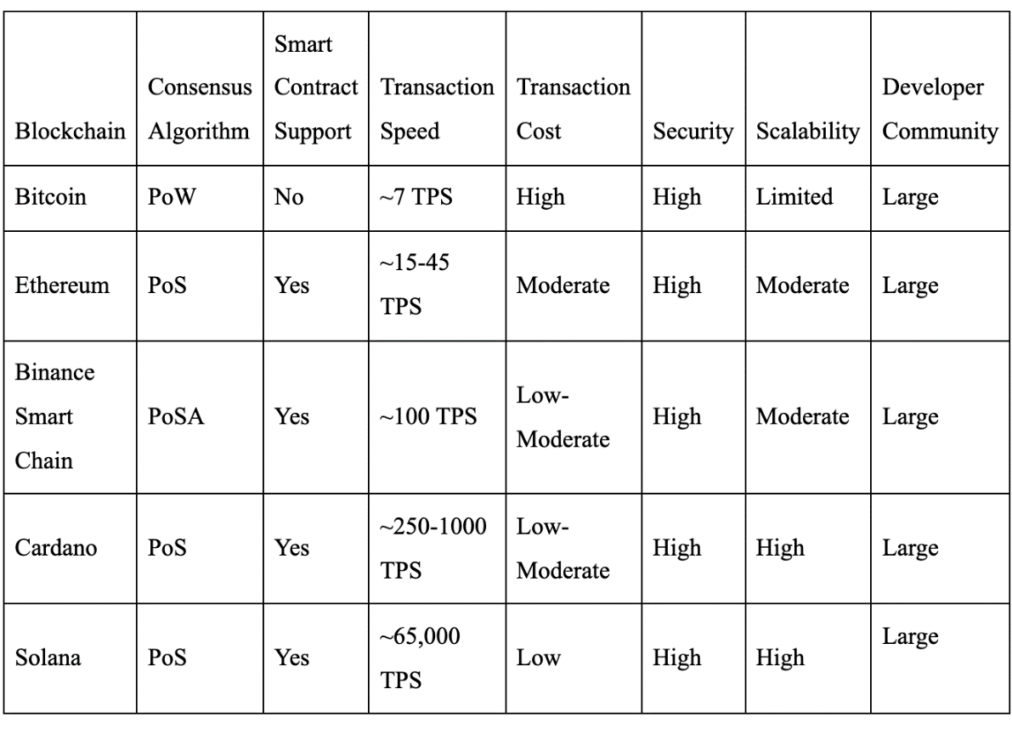
Table 4.1 shows the comparison between the various types of public blockchain. In a second-hand car trading application where just the car history is kept on the blockchain, Ethereum is a viable option.
Some features of Ethereum are listed below:
- Consensus Algorithm: Ethereum utilises the Proof of Work (PoW) consensus method, a safe and dependable technique that guarantees the legitimacy of network transactions.
- Smart Contract Support: Smart contracts, which are self-executing contracts with the details of the agreement between the buyer and seller being directly encoded into lines of code, have considerable support on Ethereum. Smart contracts may be used in the context of a used vehicle trading application to guarantee that ownership is transferred safely and that the automobile history is accurate and visible.
- Transaction Speed: While not as quick as other blockchains like EOS or TRON, Ethereum's current transaction speed of 15 transactions per second is still more than enough for applications like the second-hand automobile trade where transactions do not take place instantly.
- Transaction Cost: In comparison to other blockchains, Ethereum's transaction costs, or "gas fees," are rather affordable. This is crucial for a second-hand automobile trade application since it must have minimal transaction costs to be usable by a variety of users.
- Security: A huge network of nodes and the PoW consensus method make Ethereum one of the most secure blockchains currently in use. This makes it the perfect option for a situation involving the sale of used cars, when security is crucial.
- Developer Community: One of the biggest and busiest developer communities in the blockchain industry is that of Ethereum. This indicates that there are many resources readily available for programmers wishing to create apps for the Ethereum network, and that the platform will probably continue to get support and development in the future.
Overall, Ethereum is a great option for a second-hand automobile trading application where just the car history is recorded on the blockchain because of its strong support for smart contracts, cheap transaction costs, and high level of security. Additionally, the platform will probably continue to get maintenance and development in the future due to the sizeable and active developer community, making it a solid option for a long-term application.
4.2 CONSENSUS ALGORITHM - POW
Consensus algorithms come in a variety of forms, all of which aim to establish consensus among the nodes in a decentralised network:
- Proof of Work (PoW): PoW is The original consensus method used in blockchain networks like Bitcoin and many others is called PoW. In PoW, nodes (also known as miners) compete to find the solution to a challenging mathematical puzzle in order to validate and add a block of transactions to the blockchain. This guarantees that the network is safe and resistant to assaults but consumes a lot of processing resources.
- Proof of Stake (PoS): PoS is a PoW substitute that seeks to scale back the computational and energy costs of consensus. In a proof-of-stake (PoS) system, nodes are selected to validate blocks based on how much bitcoin they have on hand and are prepared to "stake" as security. This encourages appropriate conduct and guarantees that nodes have a stake in preserving the network's security.
- Delegated Proof of Stake (DPoS): A PoS variant called DPoS lets token holders choose a smaller group of nodes to serve as validators. Because fewer nodes are needed for consensus, transactions may be completed more quickly and with reduced costs. It may, though, also result in centralization and the concentration of power among a few nodes.
- Byzantine Fault Tolerance (BFT): Consensus algorithms in the BFT family are intended to withstand errors or malicious activity by a small number of nodes in a decentralized network. In BFT, nodes talk with one another to obtain consensus on a proposed block of transactions, and the block must be added to the blockchain after reaching consensus.
For the purpose of archiving vehicle history on the blockchain, there is no one unambiguous consensus algorithm that is superior to all others. For some use scenarios, Proof of Work (PoW) may be desirable, nonetheless, for the following reasons:
- Security: Because it takes a lot of computing power to answer the mathematical puzzle, PoW is renowned for its high level of security. Because of this, it is more challenging for attackers to modify the blockchain, which is crucial for a system that stores crucial information like a car's history.
- Decentralisation: Since everyone with a computer may take part in the validation process, PoW is also renowned for its decentralised nature. This guarantees that no single party has an excessive amount of influence over the network, which is crucial for a system that stores data and must be reliable and impenetrable.
- Established Technology: Bitcoin has been using the PoW mining algorithm for more than ten years. Due to the vast number of developers and industry professionals that have worked with PoW-based blockchains, it may be simpler to create and maintain the blockchain over time.

4.3 WHY ETHEREUM OVER HYPERLEDGER
Both Hyperledger Fabric and Ethereum are well-known blockchain platforms that have been employed in a variety of sectors. While there are certain parallels between the two platforms, there are also significant variations that solve some of Hyperledger Fabric's shortcomings.
Here are some of the disadvantages of Hyperledger Fabric that Ethereum aims to overcome:
- Complexity: Hyperledger Fabric is a complicated platform that necessitates a certain amount of technical knowledge in order to design and deploy applications. In contrast, Ethereum is intended to be more user-friendly and accessible to a broader spectrum of developers. The platform's design is simplified, making it easier for developers to get started with building decentralised applications.
- Smart Contract Language: Hyperledger Fabric's smart contract languages include Go and JavaScript, which can be difficult for developers who are unfamiliar with these languages. This may limit the number of developers who can create apps for the platform. Ethereum, on the other hand, employs Solidity as its smart contract language, which is more commonly used and has a larger community of developers who are familiar with it.
- Consensus Mechanism: Hyperledger Fabric employs a consensus technique known as Practical Byzantine Fault Tolerance (PBFT), which is a sophisticated process that necessitates a high level of coordination across network nodes. Ethereum employs a Proof of Work (PoW) or Proof of Stake (PoS) consensus process, which is simpler and more extensively employed in blockchain networks.
- Tokenization: Tokenization, the process of generating a digital representation of assets on the blockchain, is only partially supported by Hyperledger Fabric. This has the potential to restrict the types of applications that may be built on the platform. Ethereum features strong tokenization support, allowing for the development of a wide range of decentralised applications such as cryptocurrencies, stablecoins, and non-fungible tokens (NFTs).
To summarise, Ethereum seeks to overcome the shortcomings of Hyperledger Fabric by providing a simpler and more accessible platform, a more commonly used smart contract language, a simpler consensus mechanism, and robust tokenization support. Therefore, Ethereum best suits the requirements of the second-hand car trade application being developed. [9]

CHAPTER 5
PROBLEM DEFINITION
The second-hand car market is a significant part of the automobile industry, with millions of cars being bought and sold every year. However, buyers and sellers often face challenges in verifying the history of a car, including its ownership, accident history, maintenance records, and other important details.
Current solutions for verifying car history, such as vehicle history reports and government databases, are often incomplete, unreliable, and difficult to access. This can lead to disputes, fraud, and other problems in the second-hand car market.
To address this problem, we propose the development of a blockchain-based system that securely stores and manages car history data. This system would allow car owners to register their vehicles on the blockchain, providing a transparent and tamper-proof record of ownership, maintenance, and other important details.
Buyers would be able to access this information through a user-friendly interface, allowing them to make informed decisions about purchasing a used car. The system would also benefit sellers by providing a trusted record of their car's history, potentially increasing its resale value.
The system would need to address several challenges, including the integration of existing car history data sources, the development of a secure and decentralized blockchain architecture, and the creation of user-friendly interfaces for both buyers and sellers. Additionally, the system would need to comply with relevant regulations and privacy laws, while still ensuring transparency and accountability in the second-hand car market.
Overall, the development of a blockchain-based system for car history could revolutionize the second-hand car market by providing a trusted and accessible record of car history data.

CHAPTER 6
PROPOSED SYSTEM
This chapter discusses the proposed methodology through various use case diagrams and finally describes the system design with web3 application architecture and customer side application workflow.
6.1. PROPOSED METHODOLOGY - USE CASE DIAGRAMS
6.1.1 Simple Use Case Diagram
The below diagram Figure 6.1 shows Application Use Case Diagram where system administrator, Car retailer, Car maintenance, second hand car trade, Buyer and seller are the various actors involved.
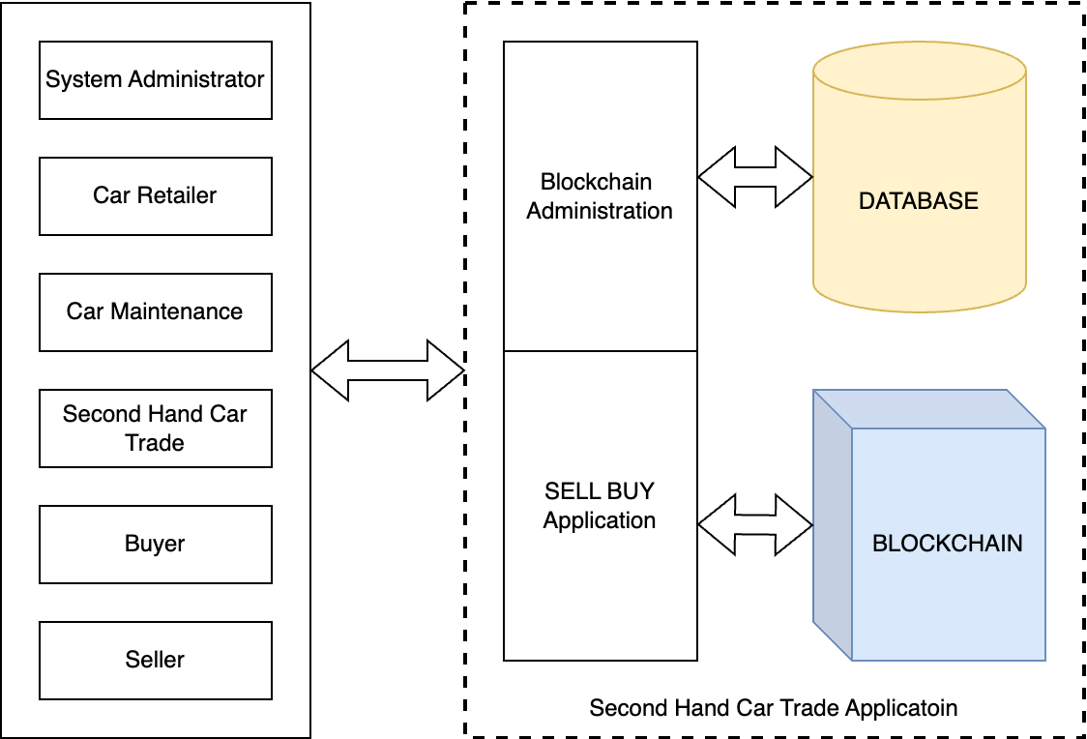
Figure. 6.1 Simple Use Case Diagram
They perform the blockchain operations on the blockchain administration application and perform the sell buy operations on the Sell Buy Application. Both the applications are connected to the blockchain.
6.1.2 Blockchain Administration - Roles And Responsibilities
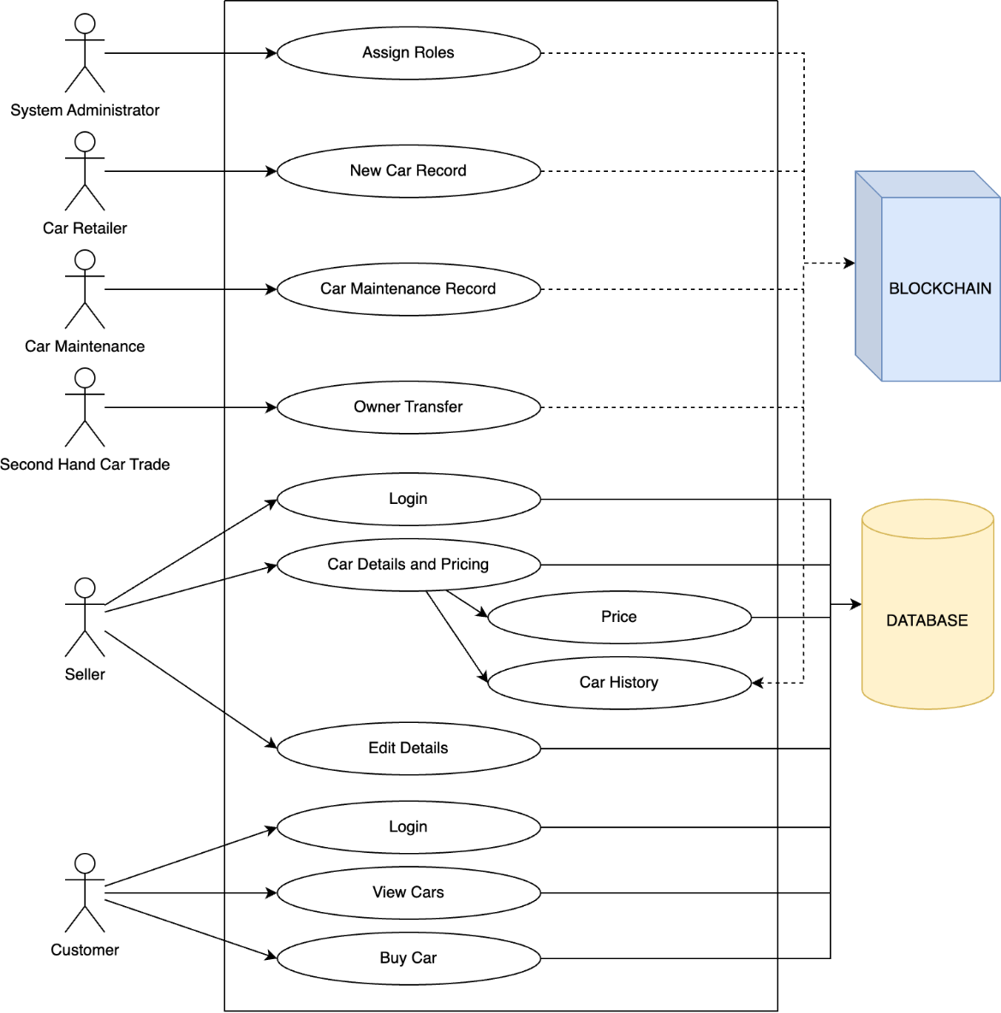
Figure. 6.2 Blockchain Administration - Roles and responsibilities
The figure 6.2 is the detailed use case diagram where each user's individual operations are shown. The seller and the buyer can’t make any changes to the blockchain but can only view the transactions whereas the other users have the power to make changes to the blockchain based on their role and privileges.
6.1.3 System Administrator Responsibilities
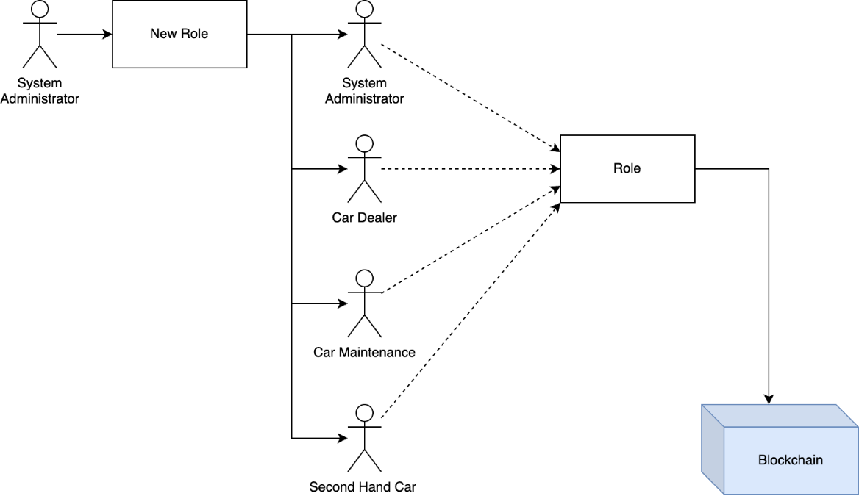
Figure. 6.3 System Administrator Responsibilities
The figure 6.3 shows how the system administrator for the blockchain had the privilege to provide users with their role namely - system administrator, car dealer, car maintenance, second hand car trade dealer. This will be stored in the blockchain, and these roles will be checked each time a transaction is made. And only the users with the appropriate role can make the transactions.

6.1.4 Blockchain transactions
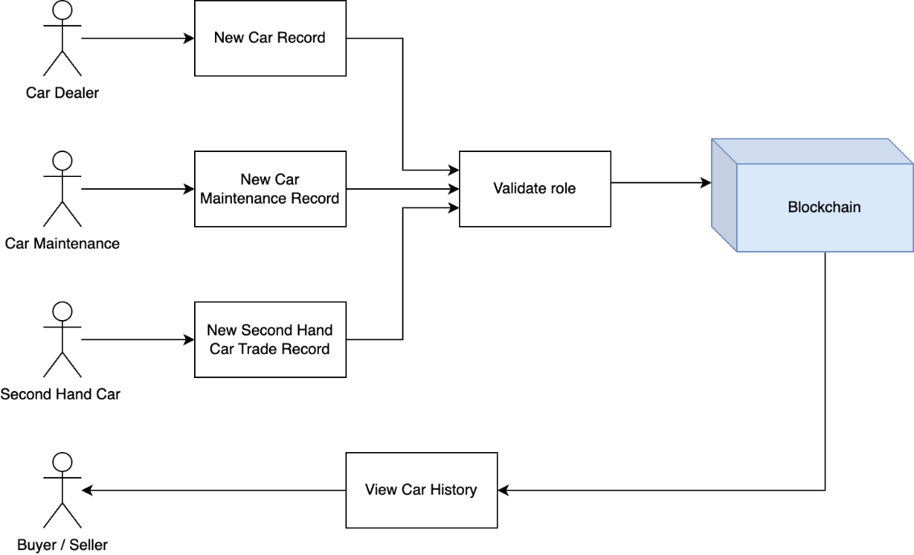
Figure. 6.4 Blockchain transactions
The various roles are car dealer, car maintenance, second hand car trade dealer, buyer/seller are shown in figure 6.4. The car dealer can create a new car sale record where the car has been retailer to customer. The car maintenance user can enter the details when a car has undergone maintenance with the appropriate details. The second-hand car dealer user will make a car ownership change as a transaction. The buyer and seller can’t make any changes to the blockchain. They can only view the history of the car directly from the blockchain using the vehicle number.
6.2. SYSTEM DESIGN
6.2.1 Web3 Application Architecture
Web3 application architecture involves the use of several technologies to create decentralized applications that interact with the Ethereum blockchain. The figure 6.5 shows the web3 application architecture.
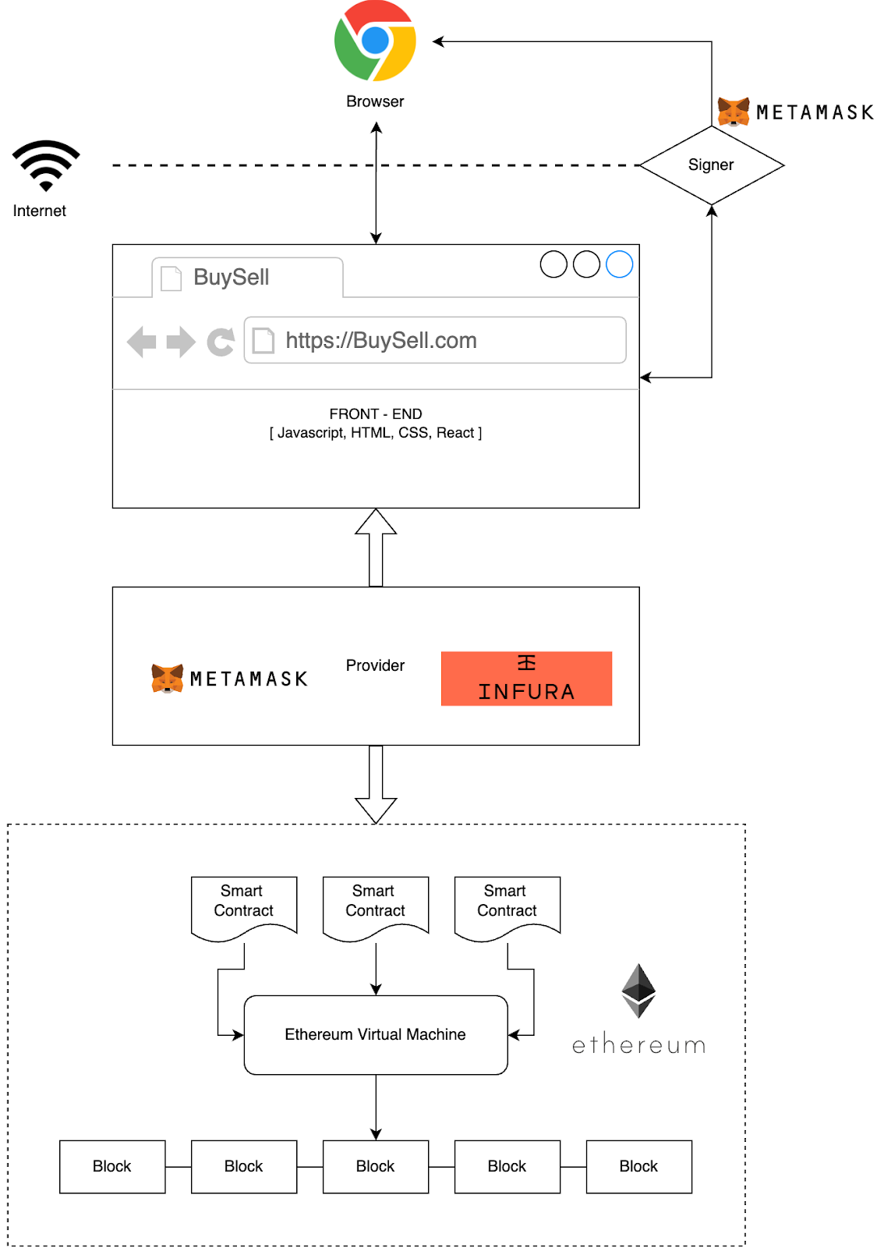
Figure. 6.5 Web3 Application Architecture

MetaMask is a browser extension that allows users to manage their Ethereum accounts and sign transactions. It provides a user-friendly interface for users to authenticate and authorize transactions, and it is compatible with several browsers.
Infura provides access to the Ethereum network via an API, allowing web3 applications to interact with the blockchain without the need to run a full node. This simplifies the development process and reduces the cost and complexity of running a node.
React is a popular JavaScript library used for building user interfaces. It allows developers to create reusable components and build complex interfaces quickly and efficiently.
Together, MetaMask, Infura, and React can be used to create web3 applications that provide a secure and user-friendly interface for interacting with the Ethereum blockchain. React can be used to build the front-end of the application, while MetaMask provides the authentication and authorization layer, and Infura provides access to the blockchain via an API. This architecture allows developers to create decentralized applications quickly and easily, without having to manage the complexity of running a full node. [15]
6.2.2 Customer Side (Buyer and seller) Application Workflow:
The figure 6.6 shows the workflow of the customer side application. The workflow depicts how seven web pages interact with each other and the flow of control between them. The seven web pages are Log in page, Register page, Buy page, Sell page, Log page, View page and View transaction history page.
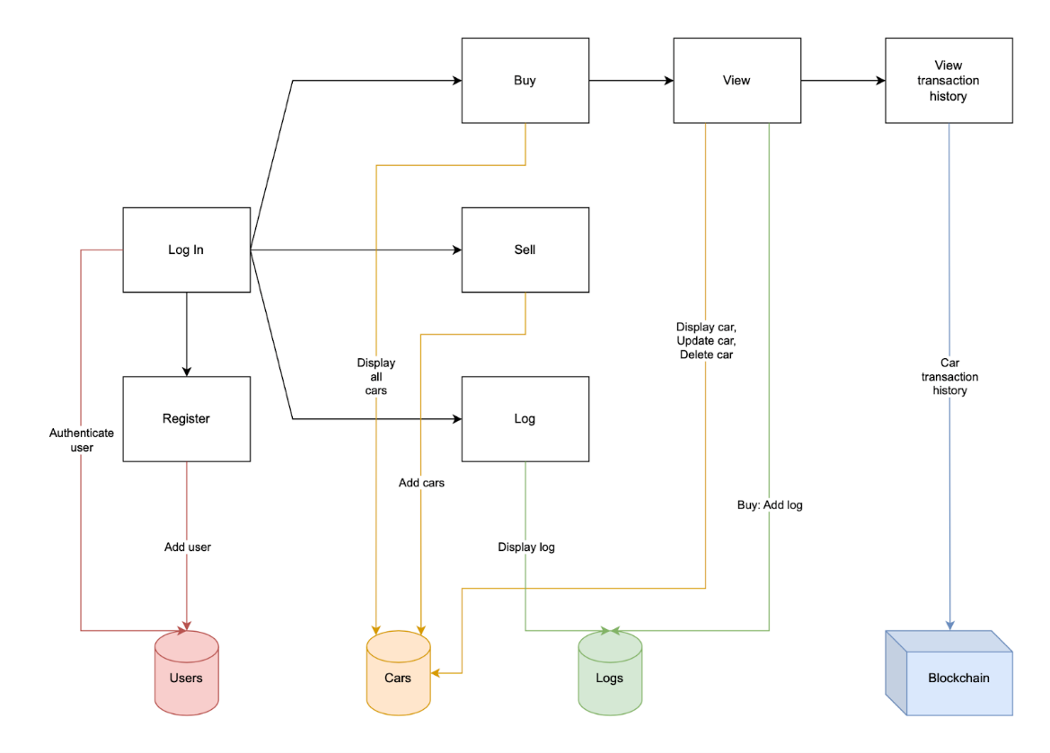
Figure. 6.6 Customer side application workflow
There are three database collections, which are used to store information related to the web application, namely Users collection, Car’s collection and Logs collection. Firstly, the users will land on the Login page, the existing user can log into the application using the username and password. New users will have to register themselves with a valid username and password. Upon successful login the users will land on the Buy page, where all the cars for sale will be displayed.
From that page, any user can view the individual car details in the View page from where the buyer has options to view car transaction history and buy the car. In the View transaction history page, the users can view the complete transaction history of the car which includes car maintenance records, car ownership transfer records, etc. Any user can sell their car in the Sell page, where the user must include some important details such as VIN (vehicle identification number), car model, price, etc. The seller has options to edit the car details and remove the car from sale in the View car page.
The User collection deals with the functions such as add user and authenticate user. While functions such as add car, display all cars, display car update and delete car are dealt by the Cars collection. Finally, add log and display logs are dealt by Logs collection.

CHAPTER 7
IMPLEMENTATION
This chapter discusses the implementation details of the second-hand car trade application using blockchain technology. Firstly, it discusses the blockchain side application, its folder structure, setting up the MetaMask account, Infura, gives information about the solidity smart contracts and Ethereum network statistics. Secondly it discusses the customer side application, its folder structure, database models and API requests.
7.1 BLOCKCHAIN SIDE APPLICATION
This demonstrates the implementation details of the blockchain side of the application. It is through this website the user can update the car history in the blockchain. The implementation details include the web application folder structure, details of each file in the project folder, explanation about the contract, MetaMask, connection to Ethereum using Infura.
7.1.1. Folder Structure
Figure 7.1 shows the way the application folders are structured and the various functions that are performed by it.

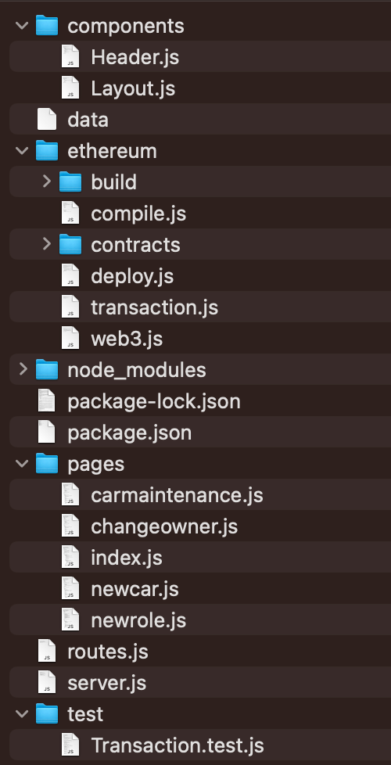
Figure. 7.1 Blockchain side application folder structure

- Components - It contains the reusable UI components of the application. Such as Header and the layout which forms the basic structure of the application.
- Ethereum - This contains the smart contract code written in Solidity programming language. It also contains the compiled smart contract bytecode and Application Binary Interface (ABI). The folder may also include deployment scripts, testing scripts, and other utility files related to Ethereum network integration.
- build: This folder contains the compiled output of the Solidity smart contract. It includes the bytecode that is deployed to the blockchain, as well as the ABI (Application Binary Interface) that describes the contract's functions and data.
- compile.js: This script is used to compile the Solidity smart contract into bytecode and ABI. It uses the Solidity compiler to perform this task.
- deploy.js: This script is used to deploy the compiled Solidity smart contract to the Ethereum network. It requires a Web3 provider to connect to the network and a private key to sign transactions.
- transaction.js: This script is used to interact with the deployed smart contract by sending transactions to it. It uses Web3 to connect to the network and sign transactions with the private key.
- web3.js: This is a library that provides an interface for interacting with the Ethereum network. It can be used to connect to a Web3 provider, such as Infura, and to send transactions and interact with deployed contracts.
- contract: This folder contains the Solidity smart contract code. It defines the contract's functions, data structures, and events, and is compiled into bytecode and ABI by compile.js.
- Node Modules - The node modules folder in a project typically contains all the dependencies installed using Node Package Manager (npm) or Yarn. These dependencies include various libraries and packages required for the project to function properly. The folder can be quite large and is automatically generated when dependencies are installed using npm or Yarn.
- Pages - contains the top-level components that correspond to the different pages or routes of the application. These components are responsible for rendering the main content of the page and may contain child components or sub-routes. Each page component is typically associated with a specific URL path and is responsible for fetching any necessary data from APIs or other sources, as well as handling user interactions and state changes.
- carmaintenance.js: This file contains the code for the page where the user can enter the maintenance history of a car.
- changeowner.js: This file contains the code for the page that allows the user to change the owner of a car. It verifies the user's credentials and updates the ownership record of the car.
- index.js: This file is the entry point of the application and renders the main page of the application. It also contains the routing information for the application.
- newcar.js: This file contains the code for the page that allows the user to add a new car to the system. It verifies the user's credentials and creates a new record for the car.
- newrole.js: This file contains the code for the page that allows the user to add a new role to the system. It verifies the user's credentials and creates a new record for the role.
- Test - This is a test file for the smart contract Transaction. The tests cover the deployment of the contract, the assignment of roles, and the verification of their validity. The tests use the Ganache provider, the Web3 library, and the contract's compiled ABI. The tests ensure that only the admin role is initially assigned, and then verify that each additional role can be successfully assigned by the admin.
The script uses ganache-cli to run a local Ethereum network, Web3 to interact with the blockchain, and assert to test for expected values.
7.1.2. MetaMask Account
MetaMask is a browser extension that allows you to interact with decentralized applications (DApps) on the Ethereum blockchain. It serves as a wallet to store and manage your cryptocurrency assets and allows you to sign transactions and authenticate with DApps. Figure 7.2 shows the MetaMask accounts opened on the user’s browser. Figure 7.3 shows the selection of network in MetaMask.
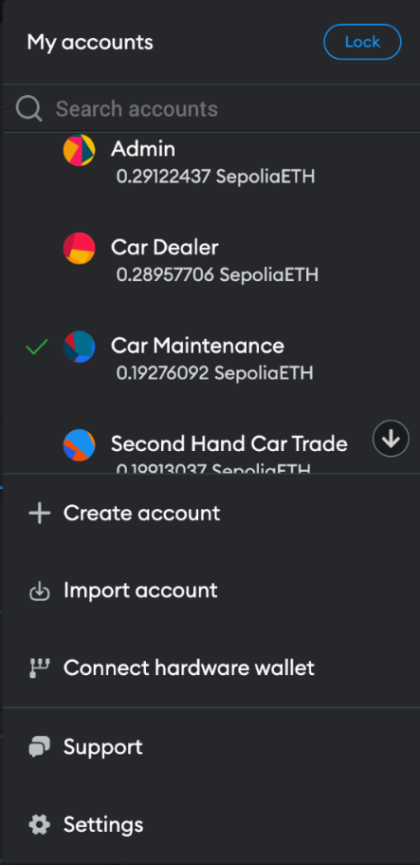
Figure. 7.2 MetaMask accounts
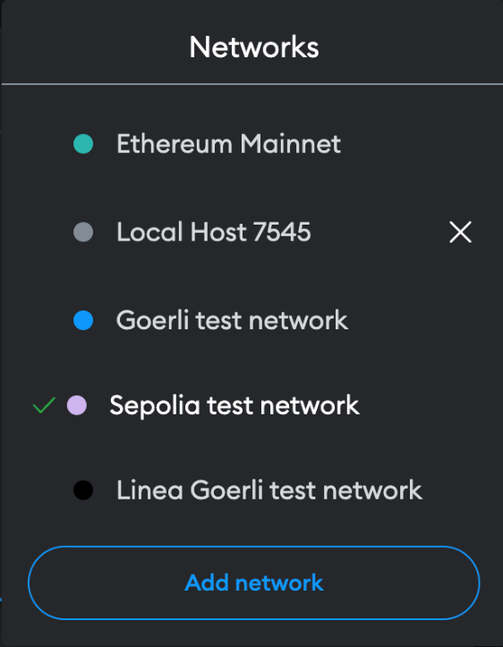
Figure. 7.3 MetaMask networks - Sepolia test network
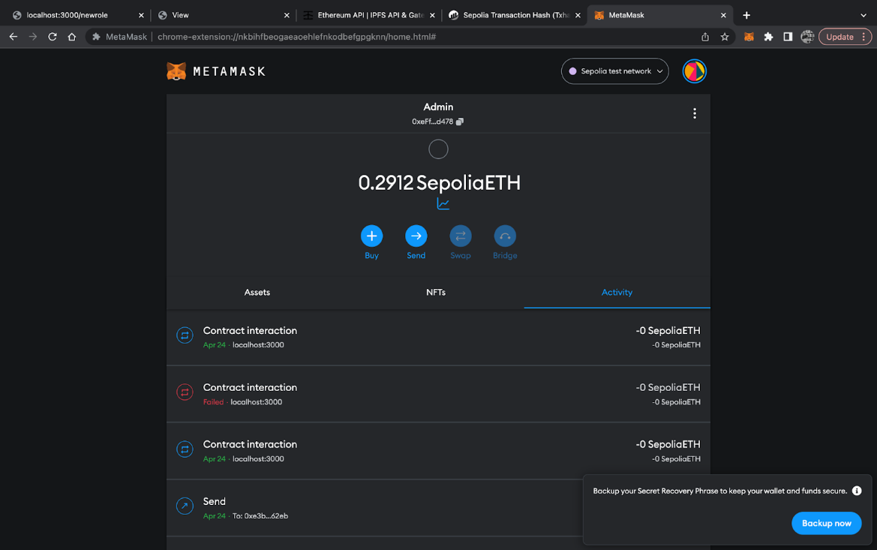
Figure. 7.4 MetaMask admin account
- Accounts are used to store and manage your cryptocurrency assets. Each account has a unique address that you can use to send and receive transactions. You can create multiple accounts in MetaMask and easily switch between them. Additionally, you can also view the transaction history, balances, and other details of each account within the MetaMask interface. Figure 7.4 shows the admin account.
- Networks refer to different blockchain networks that you can connect to. MetaMask allows you to switch between different networks, such as the Ethereum mainnet, testnets like goerli, sepolia etc. Each network has its own set of nodes that process transactions and smart contract interactions.
- Infura is a web service that provides access to Ethereum nodes. The Sepolia test network is one of the Ethereum test networks that can be accessed through Infura. By using Infura, developers can interact with the Ethereum network without having to run a node themselves. This can be useful for testing and development purposes. [12] [13]
7.1.3. Infura
Infura is a web3 provider that allows developers to connect to the Ethereum network without having to run their own node. It provides access to the Ethereum network via API endpoints, which developers can use to interact with smart contracts, send transactions, and perform other tasks on the blockchain. Figure 7.5 shows the project second hand car trade created in Infura and the API key. Figure 7.6 shows the Infura statistics. [11]
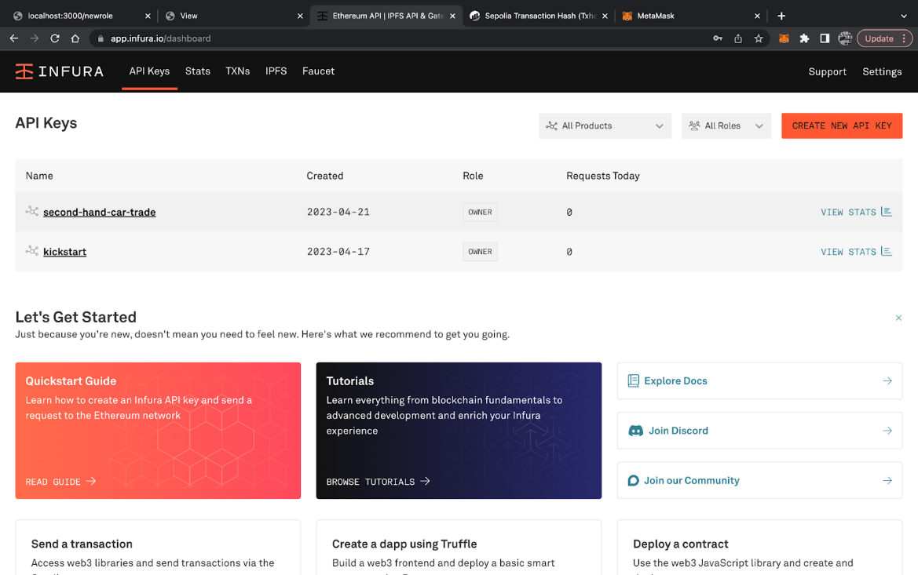
Figure. 7.5 Infura - API keys
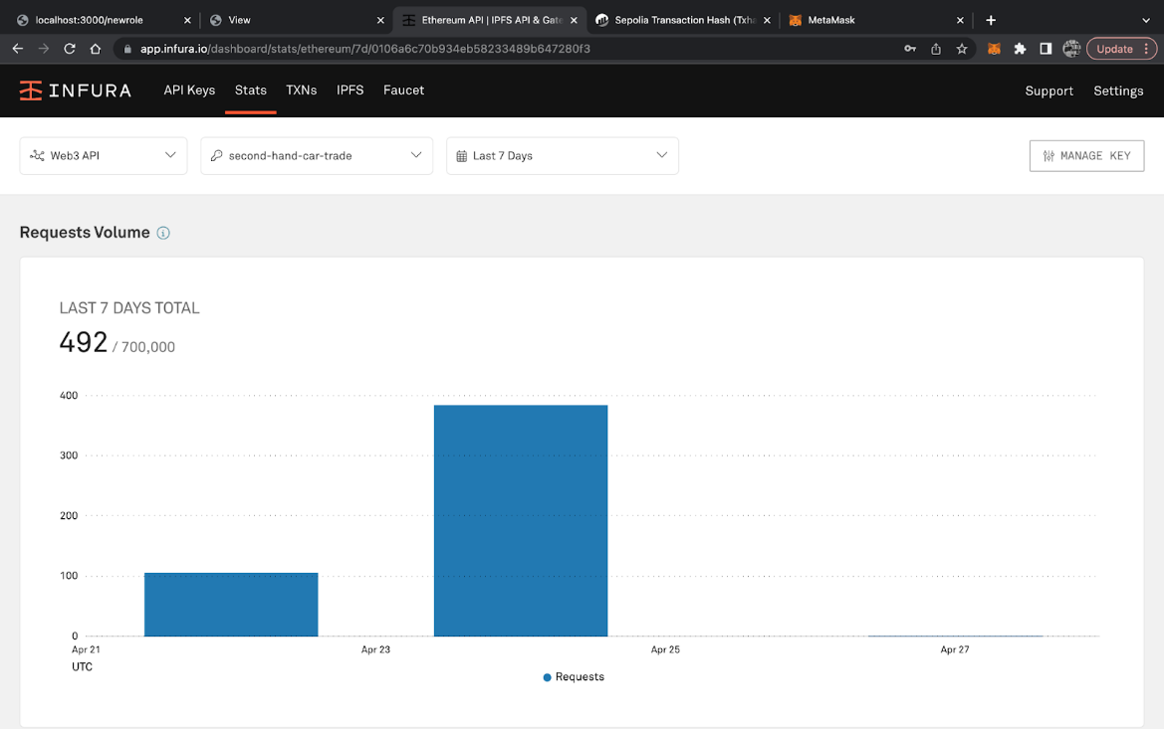
Figure. 7.6 Infura - Stats
7.1.4. Solidity Smart Contract
A Solidity smart contract is a self-executing code that runs on a blockchain network, enforcing predefined rules and conditions agreed upon by its participants without the need for intermediaries. It is written in the Solidity programming language and is immutable once deployed. [14]
- It defines four mappings: admin, carDealer, carMaintenance, and secondHandCarSale, each mapping to a Boolean value indicating whether an address is authorized to perform certain actions in the contract.
- It defines a struct called transactionDetails that stores the details of a car transaction, including VIN (Vehicle Identification Number), date, location, and additional details.
- It defines two mappings: carHistory and transactionCount. carHistory maps a VIN to an array of transactionDetails, representing the history of all transactions for that car. transactionCount maps a VIN to a number indicating how many transactions have been made for that car.
- It defines a constructor that sets the contract deployer's address as an admin. It defines four modifiers: restricted, restrictedToCarDealer, restrictedToCarMaintenance, and restrictedToSecondHandCarSale. These modifiers are used to restrict access to certain functions to specific addresses.
- It defines four functions to add addresses to the admin, carDealer, carMaintenance, and secondHandCarSale mappings.
- It defines three functions to add new transactions to the carHistory mapping. The newCar function can be called by car dealers, the maintenance function can be called by car maintenance providers, and the changeOwner function can be called by second-hand car sellers.
- It defines a function called displayAll that returns an array of transactionDetails for a given VIN. This function can be called by anyone and is used to view the transaction history of a car.
7.1.5. Web3
Web3 is a collection of libraries and protocols that allow developers to build decentralized applications (DApps) on top of blockchain networks such as Ethereum. It provides a way for DApps to interact with blockchain data and smart contracts using programming languages like JavaScript.
7.1.6. Testing And Ethereum Network Statistics
- Mocha Contract Testing:
Figure 7.7 shows the various test performed on the smart contract using mocha testing tool.
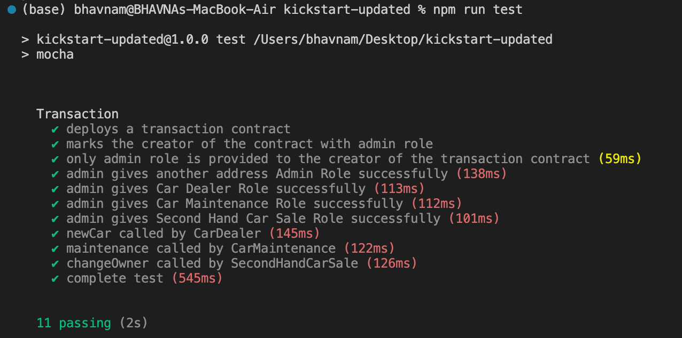
Figure. 7.7. Mocha contract testing
The smart contracts have been tested with mocha, a simple and flexible structure for writing test cases for smart contracts and other blockchain-related applications. Mocha allows developers to write tests in a behaviour-driven development (BDD) style, making it easy to express the expected behaviour of their code.
A set of simple tests have been developed to deal with all the basic test cases and to ensure all the functions are working properly.
- Transaction throughput:
Transaction throughput refers to the number of transactions that can be processed within a given time period by a particular blockchain network. It is an important metric to evaluate the performance of a blockchain network as it indicates the capacity of the network to handle a large volume of transactions. It is typically measured in transactions per second (TPS).
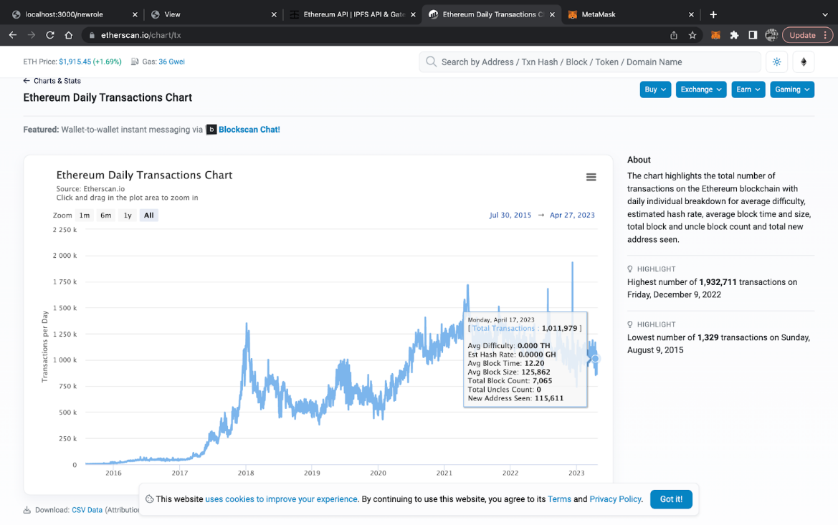
Figure. 7.8 Ethereum daily transactions chart
The figure 7.8 shows the chart highlights the total number of transactions on the Ethereum blockchain with daily individual breakdown for average difficulty, estimated hash rate, average block time and size, total block and uncle block count and total new address seen.
Network transaction throughput - 1,011,979 transactions per day
Having an average block time - 12.20 sec
- Resource consumption/ transaction fee:
Transaction fee refers to the amount of cryptocurrency paid by a user to the miners or validators of a blockchain network in order to have their transaction processed and confirmed on the network. The transaction fee serves as an incentive for miners or validators to prioritize and include the user's transaction in the next block of transactions on the blockchain. The fee amount can vary depending on factors such as network congestion, transaction size, and gas price.
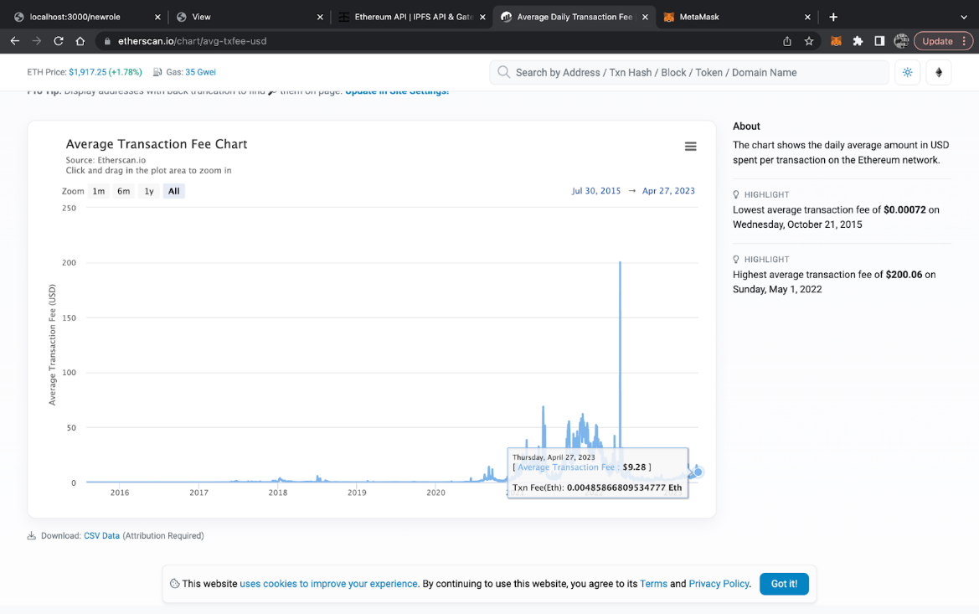
Figure. 7.9 Average transaction fee chart
The figure 7.9 shows the average transaction fee chart.
Average Transaction Fee - 0.00485866809534777 Eth
- Gas usage
Gas is the unit used to measure the computational effort required to execute a particular operation or contract on the network. Gas usage refers to the amount of gas used by a particular transaction or contract execution. Gas usage can vary depending on the complexity of the operation or contract, as well as the current network conditions such as congestion and gas prices. Figure 7.10 shows the Ethereum average gas price chart.
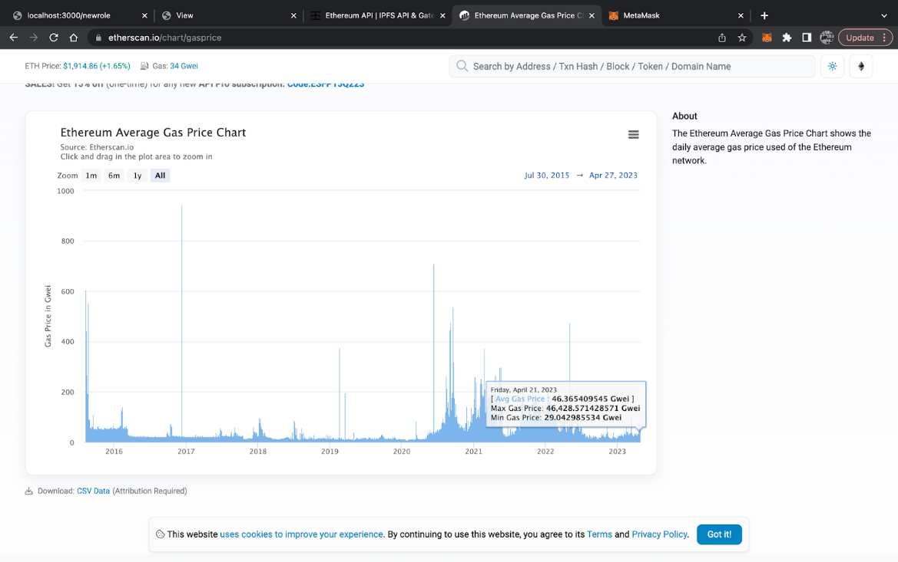
Figure. 7.10 Ethereum average gas price chart
Max Gas Price - 46438.57 Gwei
Min Gas Price - 29.04 Gwei
- Execution time
Execution time refers to the time it takes for a smart contract to execute its code and complete its tasks on the Ethereum network. It depends on various factors, such as the complexity of the code, the number of transactions it is processing, and the resources available on the network. Figure 7.1 shows the Ethereum average block time chart.

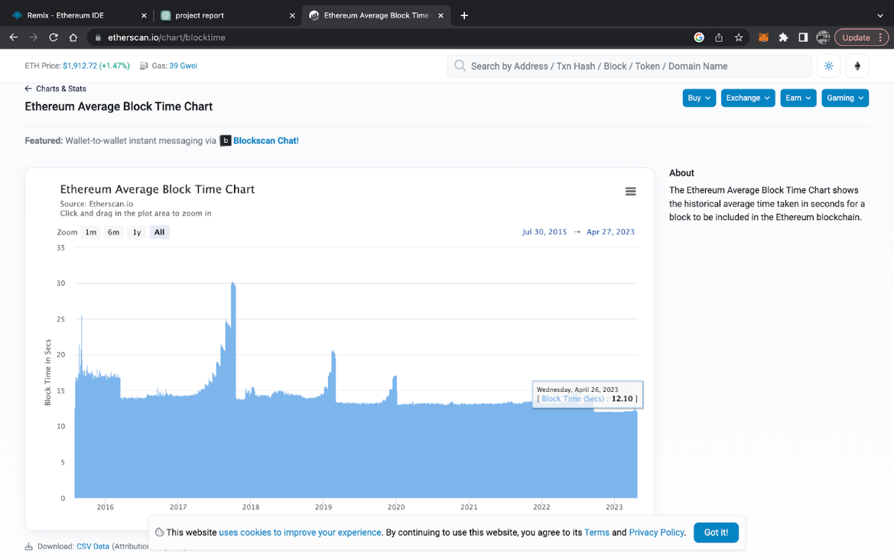
Figure. 7.11 Ethereum average block time chart
Average Block time - 12.10 sec
7.2. CUSTOMER SIDE WEB APPLICATION
The following corresponds to the implementation details of the customer side web application. The implementation details include the web application folder structure, details of each file in the project folder, explanation about the mongoose schema and explanation about each API requests separately.
7.2.1. Web Application Folder Structure
Figure 7.12 shows the folder structure of the customer side application.
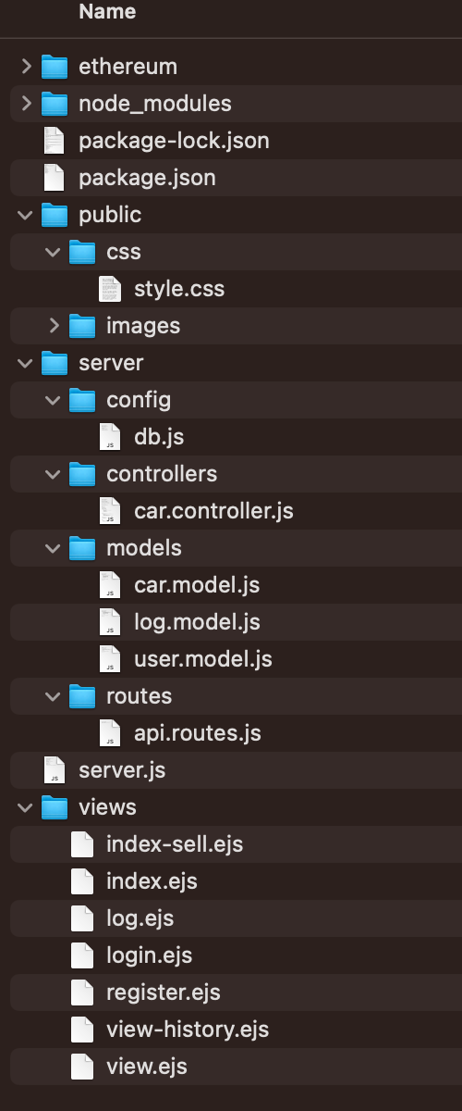
Figure. 7.12 Customer side application - folder structure
- The node_modules folder contains all the node packages necessary for the development of this web application.
- Package.json file contains the metadata of the application, such as project name, version, description, etc., and has the list of dependencies of the project.
- The public folder is a special directory in Express, which stores all the static files such as CSS files and images.
  - The CSS folder inside the public folder contains the style sheet “style.css”.
  - The images folder has all the images used for the application.
- The server folder contains JavaScript files used for the server side of the application such as configuration files, controllers, models and routes.
  - The Config folder contains the database (MongoDB) configuration file.
  - The Controllers folder contains the car controller folder, which routes different API requests correspondingly.
  - The model folder contains the mongoose models used to interact with the MongoDB.
    - Users.js - Describes the user model. It consists of id (unique and required, autogenerated), username (required) and password (required).
    - Car.js - Describes the car model. It consists of id (unique and required, autogenerated), ownerId (required), vin (required), model (required), price (required), owner (required), description.
    - Log.js - Describes the log model. It consists of id (unique and required, autogenerated), sellerId (required), buyerId (required), vin (required), model (required) and price (required).
  - The routes folder manages all the routes in this application.
- The server.js file is the main file in the NodeJS application. It is used to set up and run the web server (here using Express framework). It is in the root directory of the project and acts as the entry point to the application.
- The views folder has all the views rendered in the application.
  - Register.ejs - It contains the registration form to register users.
  - Login.ejs - It contains the login form, which takes username and password.
  - Index.ejs - It is the homepage any user views after logging into the application, it displays all the cars listed for sale.
  - Index-sell.ejs - It contains the sell form which takes the car information and adds them to sale.
  - View.ejs - It displays the individual car’s information, buy option, view car history option and a form to update and delete car information.
  - View-history.ejs - It displays the car transaction history, from the blockchain, as a table.
  - Log.ejs - It displays the buy sell log as a table.
- .env is a hidden file, which contains the configuration properties of the environment.
7.2.2. Mongoose Schema
- User schema – Table 7.1 shows the user schema used in the client-side application.
Table 7.1 User Schema
Property | Type | Details
_id | Schema.Types.ObjectId | Autogenerated
username | String | Unique, Required,  Minimum length: 3
password | String | Required,  Minimum length: 3
- Car schema – Table 7.2 shows the car schema used in the client-side application.
Table 7.2 Car Schema
Property | Type | Details
_id | Schema.Types.ObjectId | Autogenerated
ownerId | Schema.Types.ObjectId | Required
vin | String | Required
model | String | Required
price | Number | Required
owner | String | Required
description | String
- Log schema – Table 7.3 shows the log schema used in the client side application.
Table 7.3 Log Schema
Property | Type | Details
_id | Schema.Types.ObjectId | Autogenerated
sellerId | Schema.Types.ObjectId | Required
buyerId | Schema.Types.ObjectId | Required
vin | String | Required
model | String | Required
price | Number | Required

7.2.3. API Requests – Table 7.4 shows the various API requests used in the client side application.
Table 7.4 API Request
S.No. | HTTP Method | Endpoint | Description
1 | GET | / | It is the default route and renders the login page
2 | GET | /register | It renders the registration page
3 | POST | /register | The username and password are received from the request body. The password is hashed using bcrypt, now a new user is created using the username and the hashed password. It is then redirected to the login page.
4 | POST | /login | The username is received in the request body, and a query is made to the database to find the user with the given username. If a user is found, bcrypt is used to compare the password received in the request body with the hashed password stored in the database. If the password matches, a unique session ID is generated using uuid and stored in the "sessions" object along with the user's ID and username. The session ID is then set as a cookie in the response headers and the user is redirected to the buy page.
5 | GET | /logout | The session ID is retrieved from the cookie in the request headers, and the session is deleted from the "sessions" object. The "Set-cookie" header is set to clear the session cookie, and the user is redirected to the login page.
6 | GET | /buy | If the session is valid, it retrieves all the cars from the database and renders the "index" page with the cars data.
7 | GET | /sell | If the session is valid, it allows the user to enter the details of the car to be sold.
8 | GET | /log | If the session is valid, it retrieves all the logs from the database and renders the "log" page with the logs data.
9 | POST | /sell | It handles the submission of the form to sell a car. It then creates a new car object with the data received in the request body, including the current user's ID as the owner ID, and saves it to the database. Finally, the user is redirected to the buy page.
10 | GET | /view-car-history/:id | It is used to view the transaction history of a car stored on the blockchain. It takes the id of the car as a parameter, fetches the car details from the database, and then uses the Ethereum smart contract “Transaction” to fetch the transaction history of the car from the blockchain. Finally, the "view-history" page is rendered with the history data.
11 | GET | /:id | It is used to view the details of a car. It takes the id of the car as a parameter, fetches the car details from the database, and renders them in the view page.
12 | POST | /update:id | It is used to update the details of a car. It takes the id of the car as a parameter, checks the session ID cookie in the request header to get the ID of the user who is updating the car details, and then checks if the user ID matches the owner ID of the car. If the IDs match, it updates the car details in the database and redirects the user to the view page.
13 | GET | /delete/:id | It is a request used to delete the car from the database.It takes the id of the car as a parameter, checks the session ID cookie in the request header to get the ID of the user who is deleting the car, and then checks if the user ID matches the owner ID of the car. If the IDs match, it deletes the car details in the database and redirects the user to the buy page.
14 | GET | /buy-car/:id | It is a request used to buy the car. It takes the id of the car as a parameter, checks the session ID cookie in the request header to get the ID of the user who is updating the car details, and then checks if the user ID does not match the owner ID of the car. If the IDs do not match, then buy the car and add the log to the database and redirect the user to the buy page.
7.2.4. Session Management
Session management is done using cookies to maintain the user information across multiple web requests. Firstly, when the user is successfully logged in (authenticated) a session Id is generated unique to that user. The session Id is then associated with the username and user Id and stored on the server. The server then sets the cookies with the session Id generated and sends it back to the client (browser). Any subsequent web requests will be having the cookies. Figure 7.13 shows the session management.
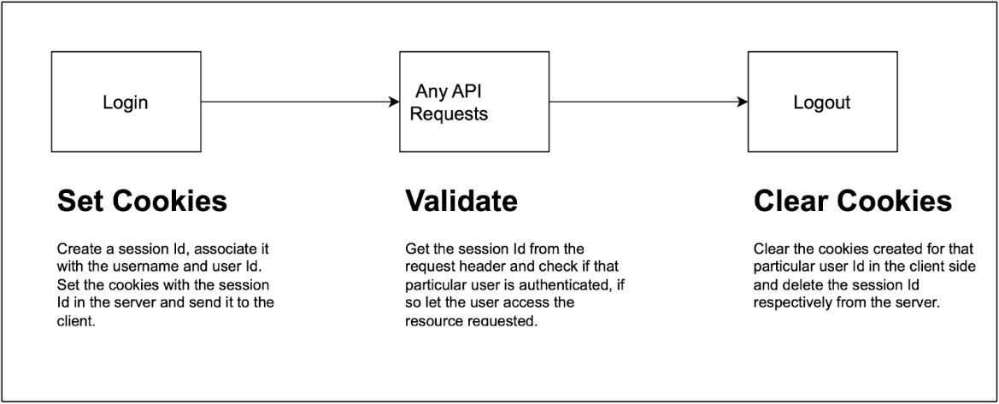
Figure. 7.13. Session management
Furthermore, the session Id is retrieved from the cookies in the request header. If that session Id is already stored in the server, then that particular user is taken as logged in, and is free to use the requested resource. Finally, when the user logs out of the application, the session Id corresponding to that user is deleted from the server and the cookies are cleared in the browser.
7.2.5. Authentication and Authorisation
All the users must have been registered with a valid username and password. Only the registered users can log into the application. The user must provide a valid username and a correct password to successfully log in to the application. The password is hashed using bcrypt and stored in the database. The username, from the request body, is first checked if it is present in the database. If so, then the password from the request body is compared with the hashed password in the database. If they are the same, then the user is authenticated successfully and can log into the application.
For authorizing the user (here seller) to edit or delete the car details, we check whether the current user’s Id is the same as the owner’s Id of the car. If they are the same, then that user can edit or delete the car details, others cannot. In this way only the users who sold that car have the edit and delete access. Likewise, the users (here buyer) can buy a car only if they haven’t sold that car. If the current user’s Id is not the same as the owner's Id, then that user can buy the car. In this way we can make sure the seller cannot accidentally buy the car he sold.

CHAPTER 8
RESULT
The Blockchain side web application is shown by the screenshots that follow. The blockchain is used to record a car's history using this application. Figure 8.1 shows adding of a new role.
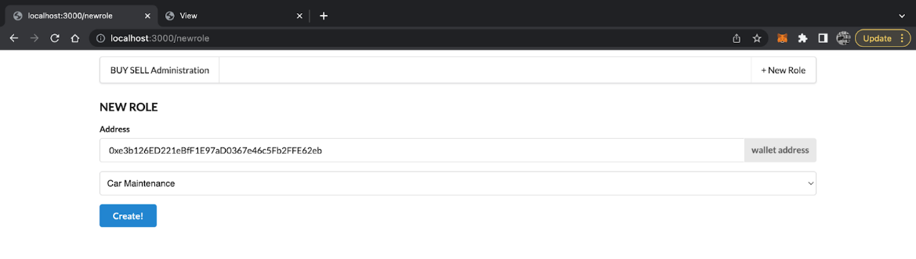
Figure. 8.1 Adding new role
It is the new role page where the system administrator can grant roles to wallet addresses. Only users who have the necessary specialised roles can execute smart contracts and make changes to the blockchain. There are four roles that can be given - admin, car dealer, car maintenance, second hand car trade dealer. Figure 8.2 shows the four roles that can be chosen by the system administrator.
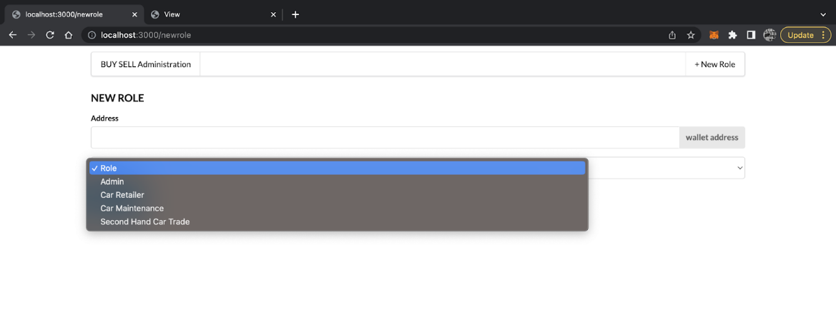
Figure. 8.2 Four roles
The system administrator can assign one of four roles: admin, vehicle dealer, automobile maintenance, or second-hand car trade dealer. Only these users will be able to make the necessary changes to the blockchain because their roles will be preserved in the blockchain.
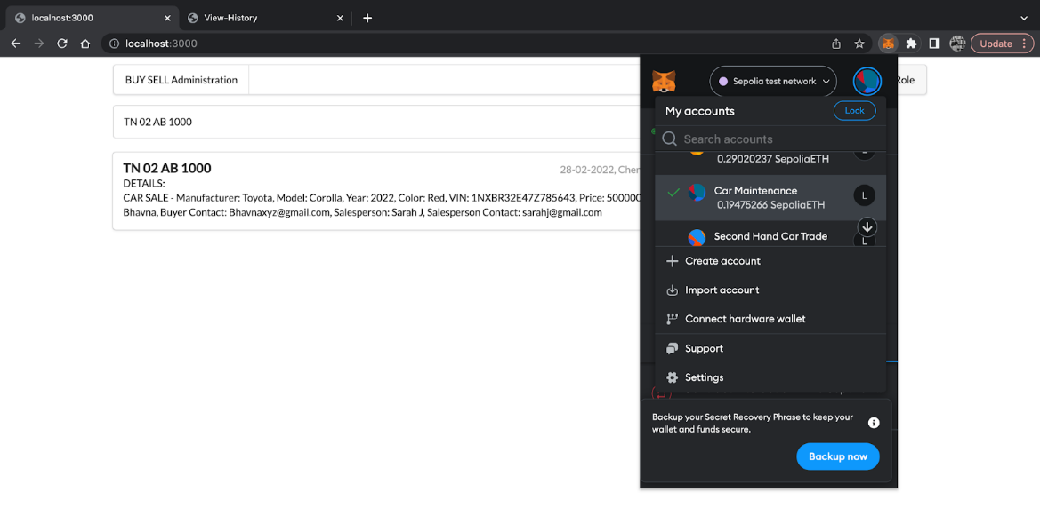
Figure. 8.3 Roles - Authorisation
Only those with the relevant role can modify the blockchain. Only users with the car maintenance role can make modifications to a maintenance record for a car. Figure 8.3 shows the roles authorisation through MetaMask.
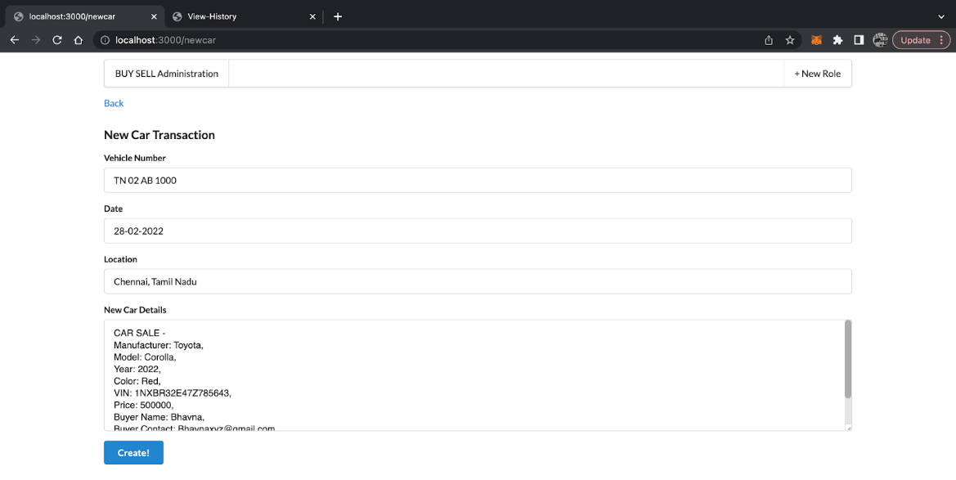
Figure. 8.4 Adding new car transaction
Figure 8.4 shows the creation of a new record -new car sale, where all pertinent information is mentioned. Only the vehicle dealer user has access to the blockchain, hence they are the only ones who can create this transaction. This takes various attributes such as vehicle number, date, location and the details of the new car.
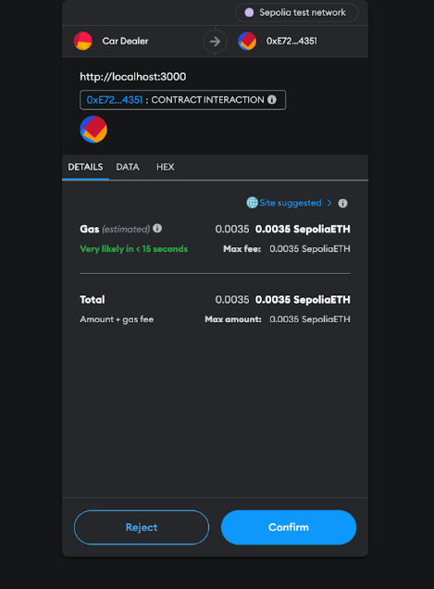
Figure. 8.5 Gas fee - for completing transaction
This is the Gas that the user would be paying to complete the transaction. MetaMask is the chrome extension that allows users to interact with the Ethereum network . A certain amount of gas and money will be spent to run the contract and make changes to the blockchain. Figure 8.5 shows the gas fee paid for completing a transaction.
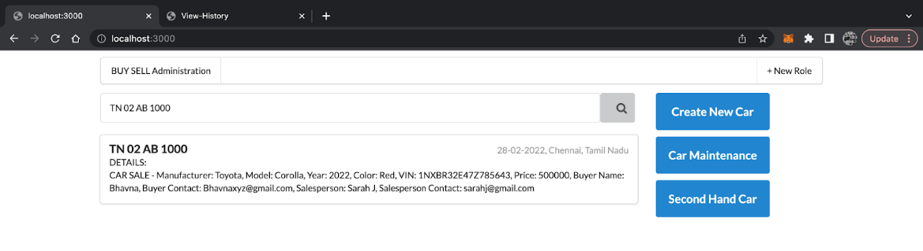
Figure. 8.6 Showing successful transaction
The record has been updated and the transaction was successful. When looking for a certain car record. We have access to a record of every transaction involving the car. Figure 8.6 shows the completion of transaction and the record being shown.
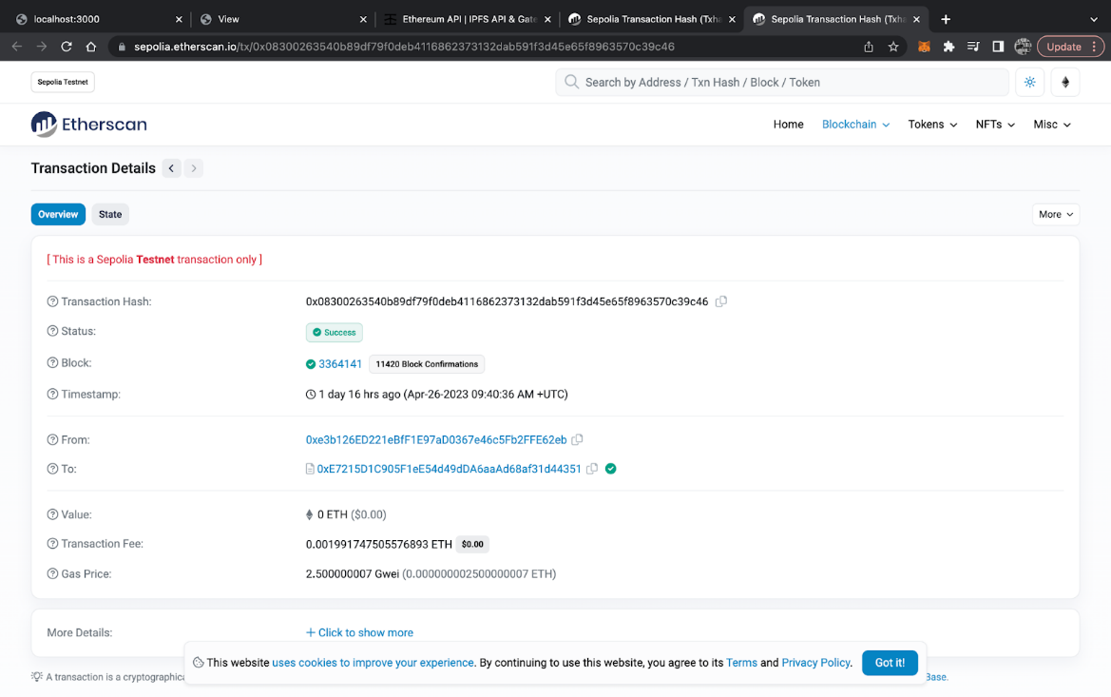
Figure. 8.7 Etherscan - Transaction details
We can view the appropriate transaction details in the public blockchain through the Etherscan website. Figure 8.7 shows all the details such as transaction hash, timestamp, transaction fee, gas price that has been paid to make the transaction.
0.0001991747505576893 ETH is a lower transaction fee compared to the average transaction fee of 0.00485866809534777 ETH. This means that the transaction with a fee of 0.0001991747505576893 ETH is relatively cheaper compared to the average transaction fee on the Ethereum network. Which is nearly 4.1% of the average transaction fee.
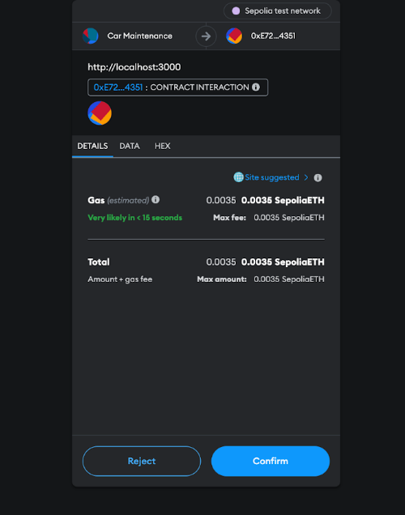
Figure. 8.8 Gas fee - for completing automobile maintenance transaction
Similar to that, a record of automobile maintenance has been made, and to complete the transaction, a specific amount of gas must be paid. Figure 8.8 shows the gas fee paid for completing the car maintenance transaction. Figure 8.9 shows the car maintenance transaction just added to the blockchain.
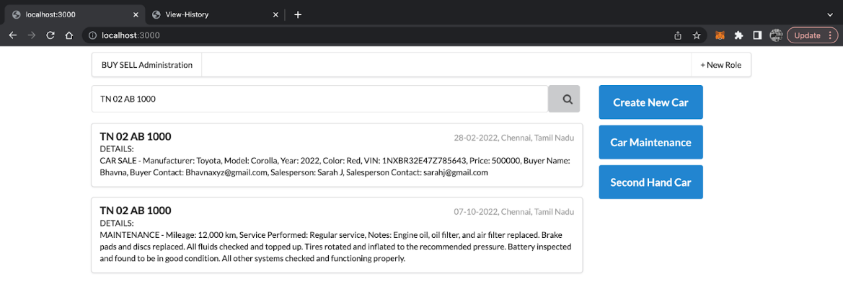
Figure. 8.9 Showing automobile maintenance transaction
After paying the required gas fee, the transaction will be reflected when searched for all the transactions involving that car. The maintenance record has also been updated.
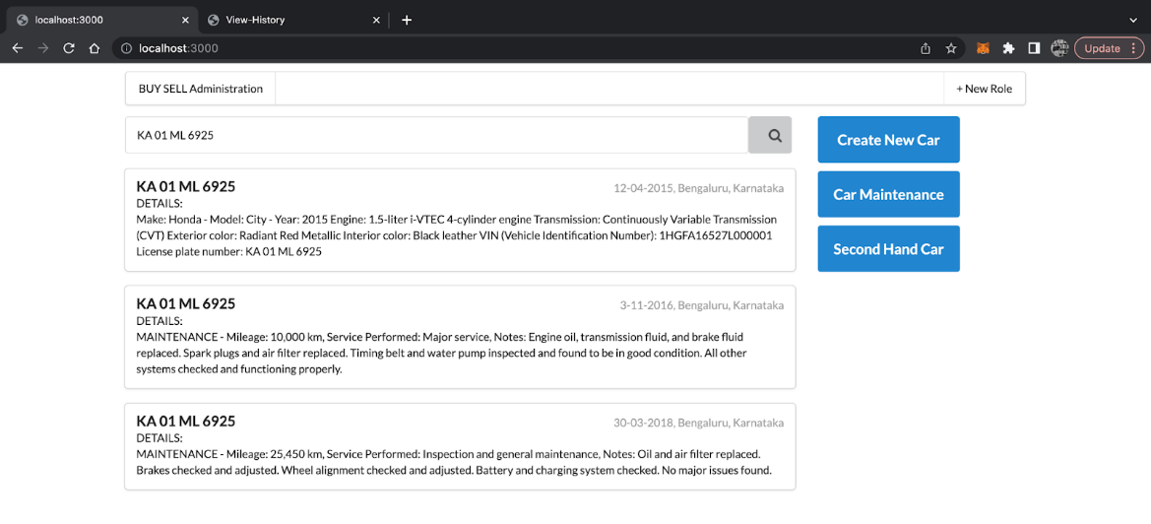
Figure. 8.10 Example of various completed transactions for a car
Here is another example of another car where various transactions have been performed. Figure 8.10 shows various completed transactions.
The following screenshots correspond to the customer side web application. The custom side web application is used by the buyers and sellers.
Figure 8.11 shows the login page, through which registered users can log into the application and use the features of the same.
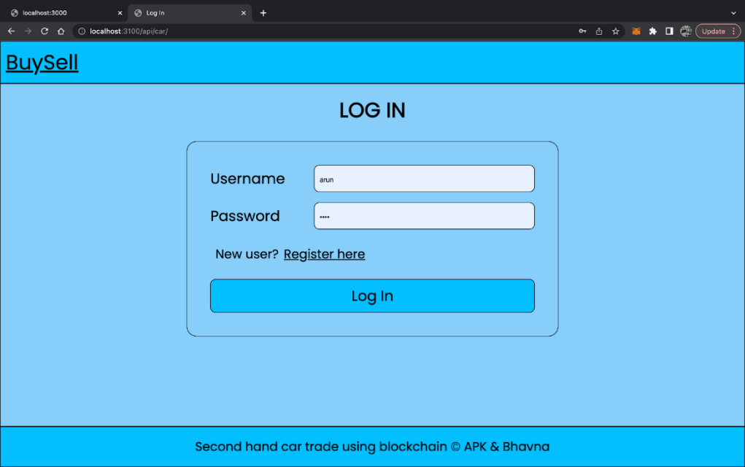
Figure. 8.11 Login page
The user should give their username and password and click “Log In”. If it is a new user, they can click “Register here” which redirects them to the registration page, where the user should register themselves with a username and password.
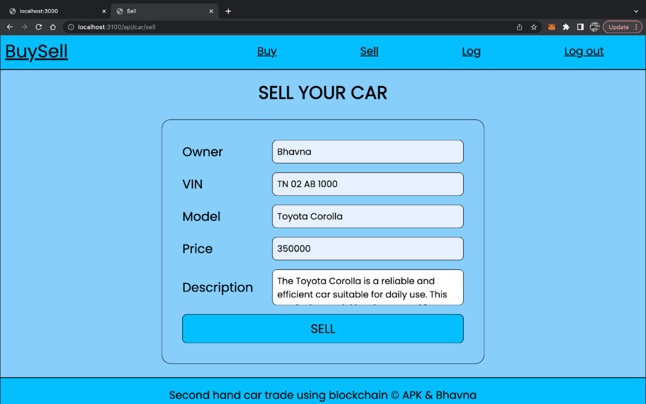
Figure. 8.12 Sell page
Figure 8.12 shows the sell page. Any user can sell their car on the “Sell” page. The user should enter the owner’s name, VIN (vehicle identification number), car model, price, description (optional).
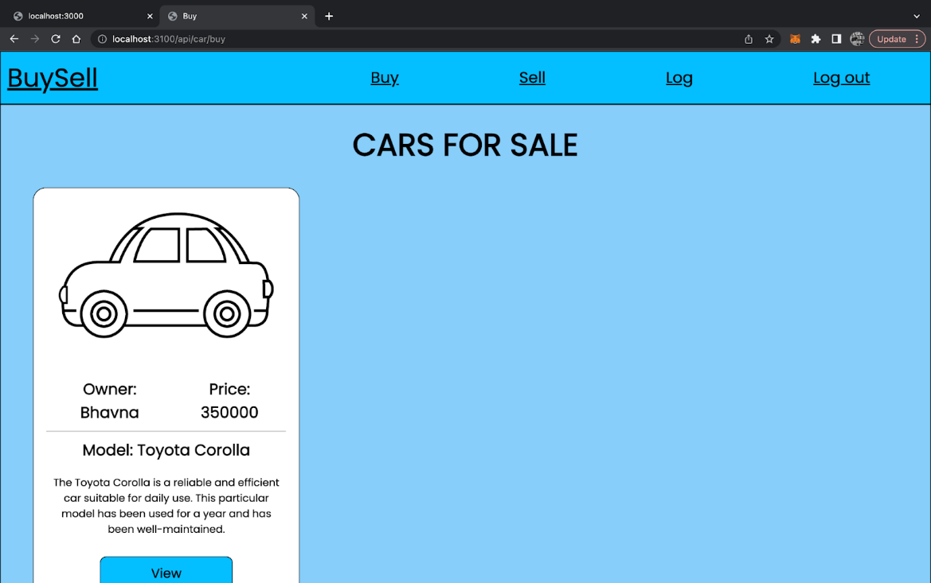
Figure. 8.13 Buy page
When any user sells their car(s), it appears on the “Buy” page. This page displays all the cars for sale as a form of cards, which shows important information such as the owner’s name, price, model and description. To view all the information and to buy the car, the user can click the “View” button of the respective car they want to see. Figure 8.13 shows the buy page.
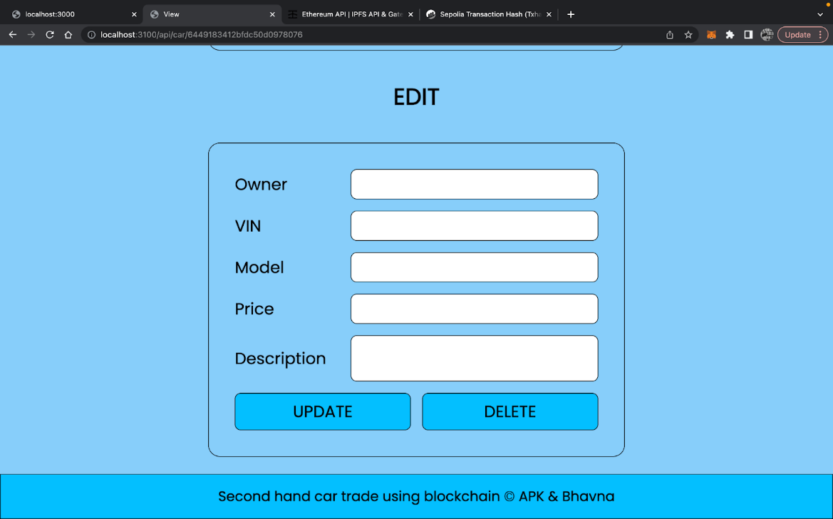
Figure. 8.14 View page - update and delete
The seller of the car has an option to edit the details of the car and even delete the car (remove the car from sale). To edit the details of the car, the user (here seller) should enter the updated details and click “Update” and to delete the car, the user should click the “Delete” button. Figure 8.14 shows the view page where you can update and delete car records.
Any user can view the car transaction details from the “View” page, by clicking the “View car history” button. The car transaction details are fetched from the blockchain and displayed here as a form of table, with VIN (vehicle identification number), Date (when was the transaction made), location and details. Figure 8.15 shows the transaction history page of the specified car.

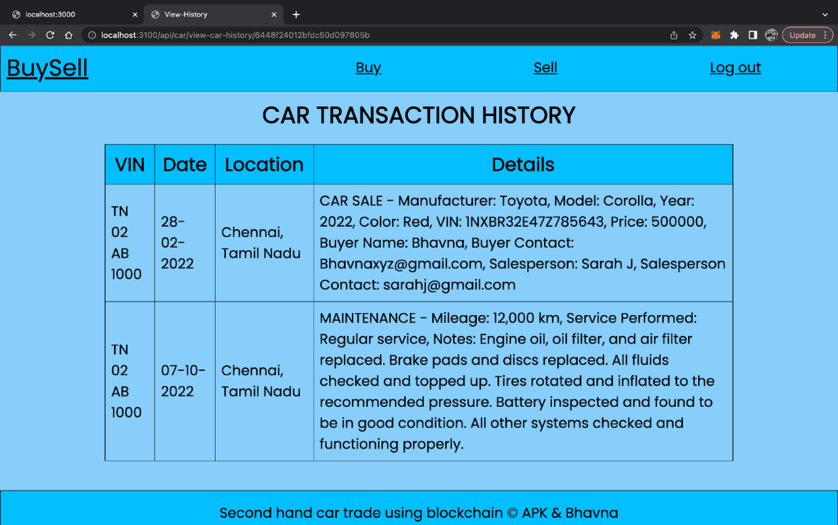
Figure. 8.15 View transaction history page

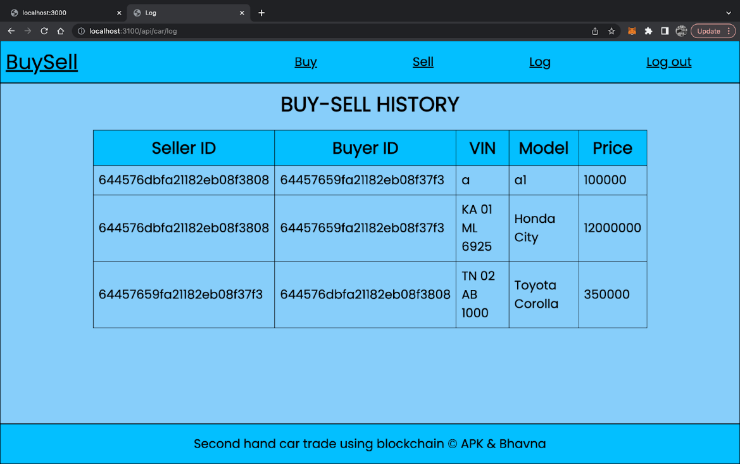
Figure. 8.16 Log page
Any user can see the buy-sell history in the “Log” page. The details such as the seller’s Id, buyer’s Id, VIN (vehicle identification number), car model and price are displayed in the form of a table. Figure 8.16 shows the log page containing all the sold cars details.
Finally, after using this web application users can log out of the application by clicking the “Log out” button.

CHAPTER 9
CONCLUSION
The creation of a second-hand automobile trade application utilizing Ethereum, Infura, MetaMask, React, and MongoDB would be a huge turning point for the automotive sector. The demand for trust and openness in the used automobile industry is addressed by the application. Buyers may confirm the accuracy of a car's history and prevent acquiring vehicles with a suspicious past by recording only the car's history on the blockchain.
The storage of the car's history data is made possible by the usage of Ethereum, a public blockchain. Without the need to set up a local node, Infura offers a gateway to the Ethereum network, making it simple to communicate with the blockchain. Users may access the blockchain through their web browser with the help of MetaMask and React offers a strong front-end framework for creating the user experience. For storing non-blockchain data, such user and vehicle information, MongoDB offers a dependable database.
Overall, this application shows how blockchain technology can build more reliable and transparent marketplaces. More applications will probably be created to fulfil similar market demands as the blockchain industry develops, and the cooperation of many technologies will continue to be essential to their growth.
9.1 CHALLENGES
- Limited adoption: Due to its relatively new and growing technology, which makes it foreign to certain users who may be hesitant to use it, the adoption of a blockchain-based application for the trading of used cars may be limited.
- Lack of a regulatory framework might lead to legal ambiguities and make it difficult to get the required permissions. There are now no clear rules or norms governing the use of blockchain technology in this industry.
- Integration with current systems: It may be difficult and time-consuming to integrate the application with several existing systems, including databases for car registration and insurance information.
- Scalability and performance: Despite the resource-intensive and slow-paced nature of blockchain technology, the application must be designed to accommodate a high number of transactions and users while also ensuring that it stays quick and responsive.
- User education and adoption: To ensure the application's acceptance, it will be necessary to invest a lot of time and energy in educating users about the advantages of adopting blockchain technology.

9.2 FUTURE SCOPE
- Integration with other blockchains: Although Ethereum is now the most well-liked blockchain for creating decentralized apps, other blockchains like Polkadot, Cardano, and Binance Smart Chain are gaining popularity. Investigating the potential for integration with social networks may provide consumers more choices and enhance the application's general usability.
- Integration with IoT devices: As more devices connect to the internet, the functionality of the application may be improved through integration with IoT devices. For instance, interfacing with the car's sensors might deliver real-time information about the performance and condition of the vehicle, which could then be recorded on the blockchain and accessed by prospective purchasers.
- Use of smart contracts for automated transactions: By automatically transferring ownership when specific criteria are satisfied, smart contracts may be used to automate the purchasing and selling process. For instance, when the buyer has paid the agreed-upon amount, a smart contract may be made to automatically transfer ownership of the automobile. This may simplify the procedure and lessen the need for middlemen.
- Decentralized finance (DeFi) integration: With the growth of DeFi, there are now more chances than ever to incorporate blockchain technology into financial services. While preserving the confidentiality and transparency of the blockchain, integrating the application with DeFi protocols might give users access to financial services like lending, borrowing, and trading.

REFERENCES
- Yadav AS, Charles V, Pandey DK and Kushwaha DS (2023), Blockchain based Secure Privacy Preserving Vehicle Accident and Insurance Registration.
- Djajasinga ND, Mutaufiq A and Hasan MR (2022), Blockchain Adoption in the Vehicle Leasing Business to Increase the Transparency of Transactions.
- Seung Gyun Yoo and Byeongtae Ahn (2021), A study for efficiency improvement of used car trading based on a public blockchain.
- Jiang YT and Sun HM. A (2021), Blockchain-based vehicle condition Recording System for Second-Hand Vehicle Market.
- Yu Y, Yao C, Zhang Y and Jiang R (2021), Second-Hand car Trading Framework based on Blockchain in Cloud Service Environment.
- You-Ting Jiang and Hung-Min Sun (2020), A Blockchain-Based Vehicle Condition Recording System for Second-Hand Vehicle Market.
- Jinyu Zhang, Honghui Zhao, Yumeng Yang and Jiaqi Yan (2019), Towards Transparency and Trustworthy: a Used-Car Deposit Platform Based on Blockchain.
- Nakamoto, Satoshi (2008), Bitcoin: A peer-to-peer electronic cash system." Decentralized business review.
- Zhao, Z. (2022, April). Comparison of Hyperledger Fabric and Ethereum Blockchain. In 2022 IEEE Asia-Pacific Conference on Image Processing, Electronics and Computers (IPEC) (pp. 584-587). IEEE.
- Shrimali, B., & Patel, H. B. (2022). Blockchain state-of-the-art: architecture, use cases, consensus, challenges and opportunities. Journal of King Saud University-Computer and Information Sciences, 34(9), 6793-6807.
- Chaganti, R., Varadarajan, V., Gorantla, V. S., Gadekallu, T. R., & Ravi, V. (2022). Blockchain-based cloud-enabled security monitoring using Internet of Things in smart agriculture. Future Internet, 14(9), 250.
- Choi, N., & Kim, H. (2019). A Blockchain-based user authentication model using MetaMask. Journal of Internet Computing and Services, 20(6), 119-127.
- Pramulia, D., & Anggorojati, B. (2020, November). Implementation and evaluation of blockchain based e-voting system with Ethereum and Metamask. In 2020 International Conference on Informatics, Multimedia, Cyber and Information System (ICIMCIS) (pp. 18-23). IEEE.
- Ayub, M., Saleem, T., Janjua, M., & Ahmad, T. (2023). Storage State Analysis and Extraction of Ethereum Blockchain Smart Contracts. ACM Transactions on Software Engineering and Methodology, 32(3), 1-32.
- Wang, Q., Li, R., Wang, Q., Chen, S., Ryan, M., & Hardjono, T. (2022). Exploring web3 from the view of blockchain. arXiv preprint arXiv:2206.08821.

